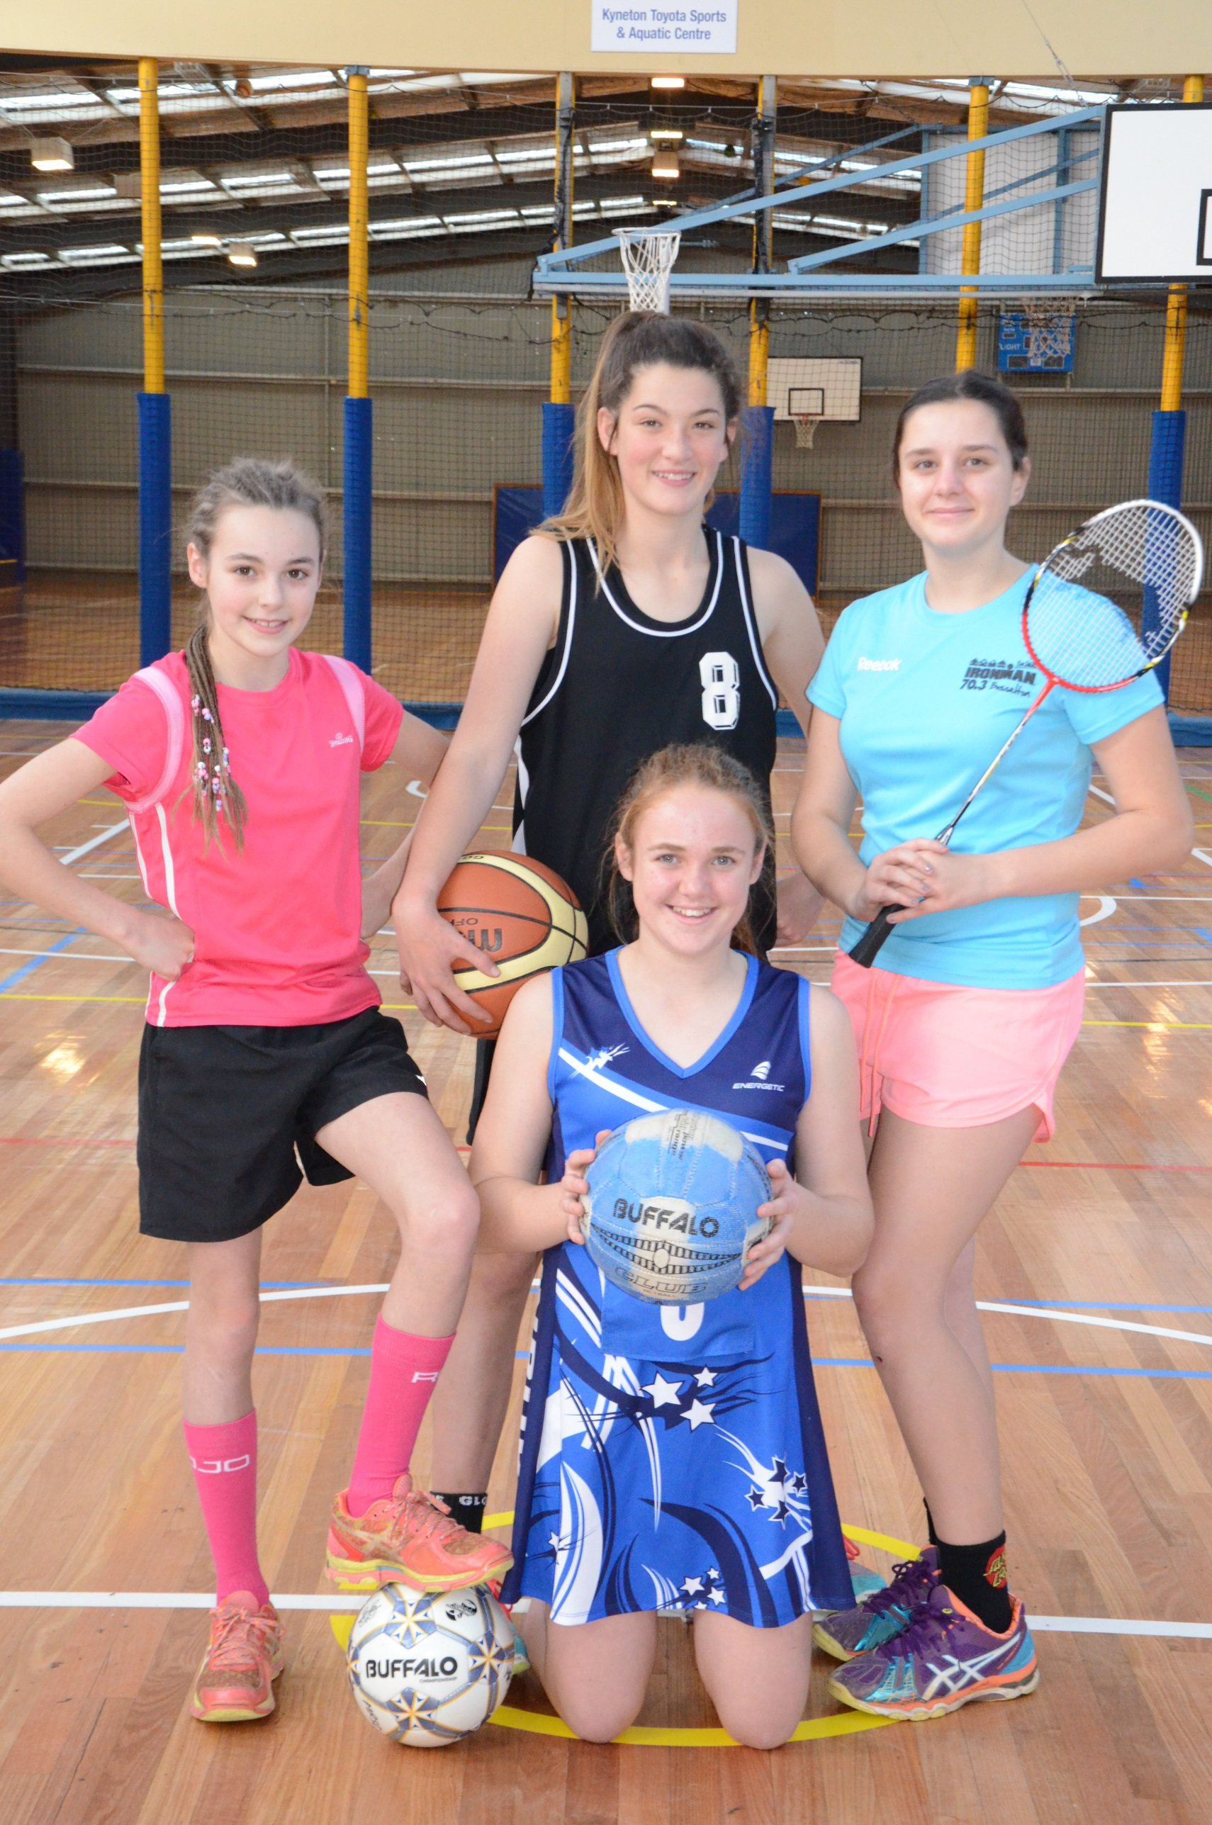****

This Strategy was developed by Macedon Ranges Shire Council with support from the Community Sports Infrastructure Fund on behalf of the Victorian Government.

**Sport and Active Recreation Strategy** 2018-2028

Background Report (Supporting Material) – Adopted by Council 27 June 2018

**Contents**

1 Sport and Active Recreation Facility Development Funding Framework 3

Introduction / Purpose 3

Definitions 3

Scope 4

Requests for Capital Works Projects 4

Process of Review and Evaluation of Capital Works Projects 4

2 Sport and Active Recreation Infrastructure Development and Maintenance Policy 7

Introduction / Purpose 7

Scope 7

Definitions 7

Guiding Directions 8

Delineation of Responsibilities for the Development / Improvement of Infrastructure 9

Delineation of Responsibilities for the Maintenance of Infrastructure 11

3. Ratio analysis 22

Township: Gisborne District 22

Township: Kyneton District 23

+ 1 Malmsbury 23

Township: Lancefield District 23

Township: Macedon and Mt Macedon District 24

Township: Riddells Creek District 24

+1 Clarkefield 24

Township: Romsey District 25

Township: Woodend District 25

4. Consultation summary report 26

Overall Themes & Issues: 26

Township Specific Summary: 27

Summary of Initial Submissions and Interviews 28

Community Survey results 40

Club Survey results 62

Summary of Submissions on Draft Strategy (2017) 89

1. **Sport and Active Recreation Facility Development Funding Framework**

Introduction / Purpose

The following Sport and Active Recreation Facility Development Funding Framework was originally presented in the 2006 Leisure Strategy. The core components of the funding framework remain relevant, minor updates have been included in the version below.

Macedon Ranges Shire Council (‘Council’) has two processes for funding the planning and development of active recreation and sport facilities and related improvement projects. These two processes are:

* Community Funding Scheme:
  + For grants of up to $6,000 administered annually.
* Capital Works Program:
  + For Council contribution of amounts greater than $6,000 Planning, evaluation and approvals process occurs concurrently with Council’s annual budget process November – May.

The Sport and Active RecreationFacility Development Funding Framework deals in detail with the second of these processes. It has been established to provide a strategic and transparent approach for the assessment and prioritisation of Capital Works projects submitted to Council for consideration. It also provides a referral process for projects and requests as they inevitably occur through the year.

Requests for Capital Works will be reviewed, evaluated, prioritised and implemented using effective processes and sound financial management practices giving due consideration to Council’s long-term strategic goals and Vision, and its ongoing operational requirements.

Definitions

1. Capital Works for Council-owned assets with a Council contribution >$6,000:
   * Purchase or construction of new assets.
   * Capital renewal of existing assets which increases the service potential or extends the life of an asset.
   * Capital expansion which extends the standard of an existing asset to provide a higher level of service.
2. Capital Works for Non Council-owned asset with a Council contribution >$6,000:
   * Contribution to another organisation’s (public or private) capital project, where such a project provides tangible benefits to the Macedon Ranges Shire community.

Scope

This funding framework will apply to all requests for Council funds required to partially or wholly fund Capital Works projects (as defined above) to create, establish or improve leisure facilities or spaces, including open space areas, recreational or sporting buildings, sports playing areas, and associated related infrastructure.

Requests for Capital Works Projects

Requests for projects to be considered for inclusion in Council’s Capital Works Program may be generated by one of the following ways:

* By resolution of Council.
* From a Councillor.
* Internally from Council, based upon the recommendations or principles contained within the Sport and Active Recreation Strategy or other relevant Council planning document or identified need.
* From the community, either by a resident or by a community organisation.
* By referral from the Community Funding Scheme or external funding program.

Process of Review and Evaluation of Capital Works Projects

**Calling For Submissions**

Council will invite clubs, committees, groups and organisations based in Macedon Ranges Shire (‘the Shire’) to submit proposals for new capital works projects each year. Timing of submission will align with requirements for consideration in the State Government’s (Sport and Recreation Victoria) Community Sports Infrastructure Fund.

All submissions should be properly costed with evidence of formal quotes or quantity surveyor estimates and include a suggested funding mix (i.e. Club/Council/other contributions requested).

Council’s Recreation and Sport department will receive and review all submissions.

**Preliminary Review**

All submissions will be initially reviewed to establish whether a project proposal:

* Is a Council responsibility.
* Is consistent with the definition of a Capital Works project.

In some instances, it may be determined that a project is more appropriate to be considered under Council’s Community Funding Scheme, and where this is the case, the project submission will be referred to this process.

**Formal Review of Eligible Submissions**

Eligible projects will be reviewed and prioritised by the Recreation and Sport department and the Director Community Wellbeing using the following evaluation criteria and weightings.

1. Fit with Endorsed Corporate Planning Strategies and Reports 25%

* Does the project help Council achieve its Vision?
* Is the project consistent with the Vision, Objectives and Principles outlined in the Sport and Active Recreation Strategy?
* Is the specific project identified in an endorsed Strategy, Master Plan or other relevant Council document, and what is its priority?
* Will the project enhance operational efficiency and sustainability?
* Is the project a responsibility of Council?

1. Participation / Involvement 25%

* Will the project improve opportunities for residents to increase participation in physical activity?
* Will the project allow additional participation programming or activities to be undertaken?
* Will the project increase opportunities for complementary multi-use?
* Will the project improve opportunities for participation in governance, management or involvement in sporting clubs/community groups?
* Will the project increase the capacity for spectators and other non-player/participants (i.e. contribute to social and community development benefits)?
* Will the project cater for disadvantaged groups and/or target groups including females, juniors and older adults?

1. Identified Need 25%

* Is there evidence of community demand?
* Is there evidence of a facility gap that the project addresses?
* Does the project address issues of safety, risk management, Universidad Design Principles and/or Environmentally Sustainable Design?
* Does the project maximise opportunities for multi-use, including by women, girls and older adults?
* Are there other community or private facilities nearby that could satisfy the identified need?
* Will the project add value to existing facilities and improve the capacity to address identified demands?

1. Financial Issues 15%

* Is external funding committed, or is the likelihood of attracting future external funding high, including government and non-government sources?
* What is the cost/benefit of the project having regard to recurrent income, expenditure and external subsidy?
* Does an economic analysis of the project confirm viability (where applicable)?
* What impact will the project have on the life of an asset?
* What impact will the project have on ongoing maintenance obligations for Council and community groups?
* Does the project demonstrate adequate planning/consideration for eventual asset renewal and lifecycle replacement?
* Have the project risks been satisfactorily managed?
* What is the funding mix for the project? Does the project maximise leveraging opportunities in the funding mix?

1. Urgency 10%

* Is the project urgent due to contractual, safety or legislative requirements?
* Will the project satisfy a government initiative or attract external support funding?
* Is there an existing Council commitment to the project?
* Does the project respond to environmental considerations or a natural disaster?

At the conclusion of the formal review process, a priority listing of all submissions will be established. Priority projects (based on the assessment results) will be considered for possible applications to Sport and Recreation Victoria’s annual Community Sports Infrastructure Fund.

The remaining projects and any other identified project will be referred to Council’s annual budget process for consideration for inclusion in Council’s Capital Works Program. This includes projects for minor capital works *($10,000 - $80,000) that do not meet the criteria for Sport and Recreation Victoria. These projects will be scored via similar assessment as per the above with a focus on:*

* *Usage and growth*
* *Implications/consequences of no action taken*
* *Club contribution to project (cash/in kind)*
* *Identified need*
* *Relevant quotes obtained*
* *Consistent with/or identified in an appropriate strategy ie master plan.*

The categories under Sport and Recreation Victoria funding programs vary from time to time but generally support projects aimed at increasing participation across all sports and active recreation activities. In some cases there are specific categories supported by the associated peak bodies (ie football)

*(For more information about Sport and Recreation Victoria’s funding programs please refer to* [*www.sport.vic.gov.au/grants*](http://www.sport.vic.gov.au/grants)*).*

1. **Sport and Active Recreation Infrastructure Development and Maintenance Policy**

Introduction / Purpose

The following Sport and Active Recreation Infrastructure Development and Maintenance Policywas originally presented in the 2006 Leisure Strategy. The core components of the policy remain relevant, minor updates have been included in the version below.

The Sport and *Active Recreation Infrastructure Development and Maintenance Policy* has been established to provide clear delineation and distinction between what is Council’s responsibility and what is a user group’s (or Reserve Committee’s) responsibility in relation to the provision and maintenance of buildings, playing areas and associated infrastructure at publicly-owned facilities. In some instances there may be shared responsibility and these are identified throughout the policy.

The outcome of the application and administration of the *Sport and Active Recreation Infrastructure Development and Maintenance Policy* will be the incremental provision and development of quality leisure facilities and spaces for Shire residents.

The Policy recognises that there has been, and is, a shared responsibility between Council and the community for the development and maintenance of sporting and recreation facilities. It acknowledges that it is not possible for Council or the community to solely and completely fund the development and maintenance of publicly-owned facilities to a level that either the Council and/or the community so desires.

The Policy also assists to enhance positive user attitudes, responsibility and ownership towards publicly-owned facilities, especially where users have contributed to their development and maintenance.

Scope

The Policy will apply to all publicly-owned sporting and recreation facilities or spaces located within the Shire, including outdoor facilities, playing surfaces (ovals, courts, greens), buildings, other supporting infrastructure (car parks, flood lights, fences, etc.) and the open space areas within or immediately surrounding the designated leisure facility.

Definitions

The following facility hierarchical definitions shall apply to this Policy:

* Regional:
  + Regional standard facilities are specialised facilities that have a large catchment (in some instances beyond the Macedon Ranges Shire) to remain viable and may require users to travel long distances. Regional facilities cater primarily for adult training and competition, and generally have a range of recreation / social areas and support facilities built to a high standard. Regional facilities should also be capable of hosting a major recreation or sporting event / tournament, such as country championships.
* Township:
  + Township standard facilities generally attract people from within the Shire only. Township sports facilities cater for training and competition, and would normally be the “headquarter” ground or centre for clubs, with additional playing facilities (if required) being accessed from Local sports facilities.
* Local:
  + Local sports facilities primarily cater for junior training and competition. Local sports facilities are generally built and maintained to a lower level when compared to Township facilities. Local sports facilities are generally used by clubs identified with a particular neighbourhood within a town.

Guiding Directions

The following Guiding Directions provide a framework, or context, for the establishment and application of the Sport and *Active Recreation Infrastructure Development and Maintenance Policy*.

1. Council acknowledges that it has a responsibility for the provision of the specific infrastructure at public sporting and recreation facilities that is required for the “game to be played” (i.e. the playing surface/area, change amenities, and designated and safe access to/from the facility).
2. Council will aim to maintain playing surfaces to a level commensurate with the level of competition that the user group(s) participates in, and the level of use that the ground receives.
3. Sporting and recreation facilities will have a basic range of infrastructure suitable for a sport to be played at the level consistent with the sport facility’s hierarchical classification of either Regional, Township or Local.
4. All new sporting and recreation facilities will incorporate Universal Design Principles and it shall be the aim of Council and user groups to have all existing facilities made accessible.
5. Council recognises the value of, and may provide incentives for, user group contributions to the capital development of facilities, the maintenance of facilities, and the replacement of artificial (or specialist) playing surfaces. (The latter through a requirement by Council in all formal occupancy agreements with user groups utilising sports facilities with artificial (or specialist) surfaces, to establish and manage an appropriate savings plan, or “sinking fund”, to meet all replacement costs, as necessary).
6. User groups will finance any approved Capital Works designed to gain income considered to be over and above a normal club’s operation, such as reserve perimeter fences (for the purpose of charging a ground admittance), advertising or sponsor signage, extensions to canteens beyond basic robust kitchen facility, , and development of and improvements to social club areas.
7. Council will enhance the long term viability of sports facilities (and user groups), by ensuring that:

* Clubs do not over-capitalise on developments.
* Clubs are able to demonstrate a sound history of fiscal responsibility, and develop appropriate and achievable funding plans, prior to approval being granted for large capital improvement projects.
* Facilities are located and designed so as to strengthen the sport and the existing club membership base, and encourage multi use by a variety of user groups where possible to do so.
* Facilities are developed and maintained in a safe state.

1. Clubs undertaking minor maintenance works must comply with relevant building codes and regulations.
2. Prior to commencement of any significant capital improvement projects, user groups shall require written approval from all other regular user groups at their respective recreation reserve, and from Council.
3. The responsibility of curating turf centre wickets and turf practice wickets will be the sole responsibility of the user group, and shall be undertaken in accordance with relevant industry guidelines.
4. Council may close any sports field as a result of wet weather or hard surfaces (or for other safety reasons) if damage to the ground or injury is likely to occur as a result of use, and/or if additional cost will be incurred by Council by that use.
5. Floodlights will be approved (subject to Town Planning approval if applicable) where an increase in sports participation is likely to result and/or to minimise risk of injury through improved management of the use of playing fields.

Delineation of Responsibilities for the Development / Improvement of Sport and Active Recreation and Sport Infrastructure.

The following table (Table 1) identifies infrastructure items and the group(s) with the whole or partial responsibility for their initial provision, and for their subsequent development and improvement. The capacity of Council to deliver its responsibilities will be dependent upon budget allocations.

As such, Council will place a priority on meeting its obligations to provide basic sporting and recreation infrastructure as outlined in Table 1 – “Council only” before assisting with “Shared” or “User Group” responsibilities.

For infrastructure where Council has no whole or partial responsibility for its provision or funding, Council may support an application by a user group to an external funding source, Council budget submission or to its Community Funding Scheme in instances where there will be community benefit, where the provision of the infrastructure is supported by an endorsed plan or strategy, or where the applicant group has been able to raise a significant proportion of the required funds for a costly infrastructure improvement item.

General conditions for all development projects:

* No fixtures, alterations or additions may be made to any part of a pavilion, playing surface or surrounding open space without written consent of Council.
* All works and improvements to any part of a pavilion, playing surface or surrounding open space must be authorised in writing by Council.

**Table 1 – Development, Improvement and Replacement Responsibilities**

| **Infrastructure Component** | **Council Only** | **User Group** | **Shared Responsibility** |
| --- | --- | --- | --- |
| **Pavilion and surrounds** | | | |
| Player change rooms, toilets, showers | * Basic provision as determined by Council | * Additions |  |
| Social Rooms |  |  |  |
| Canteen & Equipment |  |  | * Basic provision of facility (not equipment) as determined by Council |
| Meeting Room |  |  | * Council may contribute where general community usage may be applicable |
| Office |  |  |  |
| Umpires/Referees change room (provision for males/females) | * Basic provision as determined by Council | * Additions |  |
| Storage room | * Basic provision as determined by Council for new pavilions only | * Beyond basic provision |  |
| Storage (Shipping Containers) |  |  | * Shipping containers prohibited on sporting reserves, other than those instances where containers may be required to temporarily store equipment when Council/clubs undertake major works. |
| Covered area for spectators | * Basic Provision to be included in design as determined by Council |  | * In circumstances where there is high community use, such as Regional facilities |
| Public toilets |  |  |  |
| Reserve fencing | * As determined by Council | * In circumstances where tenant club is sole beneficiary of works | * In circumstances where personal safety is a consideration, e.g. roads |
| Off-street car parking (unsealed) | * For Township and Regional facilities only | * Beyond basic provision, e.g. sealing | * In circumstances where there is high community use, such as Regional facilities |
| **Playing Area** | | | |
| Sports fields (includes basic sub-surface irrigation and drainage infrastructure) |  |  |  |
| Centre cricket pitch | * For new cricket oval developments |  | * As determined by Council |
| Cricket practice nets |  |  | * In new oval developments dependent on assessments. All new cyclone fencing must be powder coated in black. |
| Perimeter fencing on sports fields | * For new oval developments as determined by Council | * For existing ovals where a fence is required by a club | * Replacement of existing fences as determined by Council. All new cyclone fencing must be powder coated in black. |
| Scoreboard |  |  |  |
| Coaches boxes | * For new oval developments as determined by Council |  |  |
| Goal posts/nets | * For new oval developments as determined by Council |  |  |
| Tennis courts/netball association courts (i.e. that hold weekly multi-club competition) | * As determined by Council | * Additional courts |  |
| Flood lighting – training standard | * As determined by Council | * Additions or improvements | * As determined by Council |
| Flood lighting – competition standard | * As determined by Council |  | * As determined by Council |
| Athletics field event areas |  |  |  |
| Outdoor netball courts at football grounds | * As determined by Council | * Additional courts, or conversion to synthetic surface |  |
| Equestrian Facilities |  |  |  |
| All other sporting facilities |  |  |  |

Delineation of Responsibilities for the Maintenance of Sport and Active Recreation Infrastructure

The following table (Table 2) outlines and refines existing maintenance responsibilities for sporting and recreation infrastructure and equipment. Council’s responsibilities are subject to resource and program allocations.

A general condition for all maintenance projects is that no fixtures, alterations or additions may be made to any part of a pavilion, playing surface or surrounding open space without written consent of Council.

**Table 2 – Maintenance Responsibilities**

Change Pavilions

|  |  |  |
| --- | --- | --- |
| **ITEM** | **COUNCIL RESPONSIBILITY** | **USER GROUP RESPONSIBILITY** |
| ***ELECTRICAL \*\**** | ***Any works undertaken must have written Council approval prior to works beginning and be carried out by an approved Council Contractor*** | |
| **Electric wiring and fittings in building** | * All building wiring from the main supply to and including the switchboard | * No responsibility |
| **Light fittings and globes** | * Repair or replace faulty fittings | * Keep clean * Replace globes/lamps (energy efficient ‘bulbs’ recommended) * Cost of repairs if damage caused by misuse * Cost of any additional light fittings required by group |
| **Ceiling fans** | * No responsibility | * Purchase, maintenance, installation, repair and replacement costs |

|  |  |  |  |  |
| --- | --- | --- | --- | --- |
| **ITEM** | **COUNCIL RESPONSIBILITY** | | **USER GROUP RESPONSIBILITY** | |
| **Exhaust fans** | * Initial installation of basic equipment only | | * Keep clean and maintain in operable condition * Cost of repair and replacement costs | |
| **Power Points** | * Repair or replace faulty power points | | * Cost of any additional power points required by group | |
| **Tag & Testing of non-hardwired electrical equipment** | * No responsibility | | * Tag & Testing as per legislation by a licensed contractor | |
| ***PLUMBING\*\**** | ***Any works undertaken must have written Council approval prior to works beginning and be carried out by an approved Council Contractor*** | | | |
| **Internal toilets** | * Installation, maintenance, repair and replacement costs due to unit age or fault | | * Internal repairs due to misuse * Keep clean and maintain in operable condition * Supply toilet paper | |
| **Plumbing and fixtures, including hot water services** | * Major maintenance * Repair or replacement due to item age or fault | | * Internal repairs due to misuse, includes shower drains blocked by dirt, grass clippings and other debris * All costs associated with additional fixtures not standard within the building | |
| **ESSENTIAL SERVICES** | | | | |
| **Fire Extinguishers, hydrants and hose reels** | * Initial installation and servicing | | * Cost of replacement due to misuse | |
| **Emergency and exit lighting** | * Installation, maintenance, repair and replacement costs | | * Report any faults to Council | |
| **Essential Services**  ***(incl. smoke alarms, fire exit doors)*** | * Maintenance of essential safety measures to an operational level * Ensure emergency floor plans are current | | * Induction of facility users * Ensure emergency floor plans are visible at all times | |
| **SECURITY** | | | | |
| **External Locks and Keys**  ***(Refer to Council’s Key Policy)*** | * Require access to the building * Require access to electrical switchboard and meter boxes * Provision of Council key safe | | * Purchase, installation, maintenance, repair and replacement costs * Cost of additional and replacement of lost keys * Ensure Council is provided a key to access the building, switchboard and meter boxes * Any change to external locks/ door hardware must be approved in writing by Council prior to works to ensure that Building Code requirements are met | |
| **Security System** | * No responsibility | | * Purchase, installation, service and maintenance * Key or PIN number must be supplied to Council | |
| **Security lighting around pavilion** | * No responsibility | | * Utility costs * Cost of any enhancements * Maintenance, repair or replacement due to age or structural fault | |
| **Vandalism (internal)** | * No responsibility except where damage exceeds Council’s excess (as at 2014 $2000). Council to submit claim | | * Report to Police & Council * Cost of all repairs up to Council’s insurance excess | |
| **Vandalism (external)** | * No responsibility except where damage exceeds Council’s excess (as at 2014 $2000). Council to submit claim | | * Report to Police & Council * Cost of all repairs up to Council’s insurance excess | |
| ***BUILDING FABRIC*** | | | |  |
| **Windows** | | * Major structural maintenance * Repair or replacement due to item age or fault | | * Keep clean * Repairs due to misuse |
| **Painting of ceilings, walls and other surfaces** | | * Initial painting as part of pavilion construction * All internal and external painting | | * No responsibility |
| **ITEM** | **COUNCIL RESPONSIBILITY** | | **USER GROUP RESPONSIBILITY** | |
| **Ceilings** | | * Major structural maintenance | | * Repairs due to misuse |
| **Doors** | | * Major structural maintenance (excluding cupboard doors and fittings) * Maintenance, repair and replacement of all external doors * Replacement of all internal doors due to age | | * Regular cleaning and repair due to misuse * Maintenance and repair of all internal doors including cupboard and storeroom doors * Any change to external locks/ door hardware must be approved in writing by Council prior to works to ensure that Building Code requirements are met |
| **Floor surfaces and coverings** | | * Initial installation of floor covering as part of pavilion construction * Major structural maintenance | | * Any repair, maintenance, upgrade and replacement costs subject to Council approval |
| **Roofs** | | * All maintenance and repair costs | | * No responsibility |
| **Skylights** | | * Maintenance, repair or replacement due to age or structural fault | | * Repair if damaged through misuse |
| **Guttering** | | * Maintenance, repair or replacement due to age or structural fault | | * No responsibility |
| **External & internal walls** | | * Structural maintenance | | * Regular cleaning * Repainting (approved Council colours) * Repair if damaged through misuse |
| **Building alterations** | | * Assessing all requests and if approved, ensuring satisfactory completion of work, even when totally funded by the user group | | * Scope and document the specific requirements of projects associated with building or facility alterations * Seek Council approval |
| **INTERNAL FITTINGS** | | | | |
| **Window coverings** | | * No responsibility | | * Purchase, installation, cleaning, repair and replacement |
| **Heating /Cooling fixtures** | | * No responsibility | | * Purchase, installation, repair, replacement and maintenance costs including six (6) monthly inspections and servicing by licensed Contractor * Payment of all running costs |
| **Other permanent fixtures** | | * Initial installation of basic equipment as part of pavilion construction | | * Regular cleaning of all fixtures and repair/replacement |
| **CANTEEN / KITCHENS *(where applicable)*** | | | | |
| **Food handling areas** | | * Initial installation of basic cupboards, sink and bench tops as part of pavilion construction | | * Keep clean and maintain in accordance with the Health Act * Upgrade and replacement costs |
| **Stoves and cooking equipment** | | * Initial installation of basic equipment as part of pavilion construction | | * Keep clean and maintain in operable condition * Repairs, maintenance, upgrade and replacement costs |
| **Refrigerators and dishwashers** | | * No responsibility | | * Purchase, installation, repair, replacement and maintenance costs |
| ***UTILITIES*** | | | | |
| **Water** | | * Initial installation of water supply as part of pavilion construction * Any required maintenance, repair, replacement or upgrade to the facilities water supply | | * All usage and supply costs |
| **Electrical** | | * Initial installation of electrical supply as part of pavilion construction * Any required maintenance, repair, replacement or upgrade to the facilities electrical supply (including main switchboard) | | * All usage and supply costs |
| **Gas** | | * Initial installation of gas supply as part of pavilion construction * Any required maintenance, repair, replacement or upgrade to the facilities gas supply | | * All usage and supply costs |

|  |  |  |
| --- | --- | --- |
| **ITEM** | **COUNCIL RESPONSIBILITY** | **USER GROUP RESPONSIBILITY** |
| **Telephone and communications** | * No responsibility | * All installation, connection, maintenance, repair, replacement, upgrade and usage/equipment costs |
| **Rubbish**  ***(within Council garbage collection district)*** | * Weekly emptying of reserve rubbish bins as part of Council’s waste contract | * Picking up of rubbish around the pavilion and reserve * Putting out bins for collection * All costs associated with garbage collection including any additional bins |
| **Rubbish**  ***(outside Council garbage collection district)*** | * No responsibility | * Picking up of rubbish around the pavilion and reserve * Removal of all rubbish * All costs associated with garbage collection |
| **OTHER** | | |
| **Pavilion cleaning** | * No responsibility | * Regular cleaning of the facility including all associated costs |
| **Covered areas for spectators – attached to building** | * Maintenance responsibility as per rest of building | * Cleaning |
| **Signage** | * Install, maintain and replace all essential signage * Install, maintain and replace all Council branded signage | * Seek Council approval before installation of signage * Install, maintain and replace all Club branded signage |
| **Pest Control** | * All structural pest control ie: termites | * All other pest control as required   ie: mice, spiders, wasps etc |
| **Other equipment / facilities added to pavilion by a Group *(incl. furniture)*** | * No responsibility | * All maintenance, repair and replacement costs * Insurance of equipment and contents |
| **No Smoking** | * Advise user groups of Council’s No Smoking Policy | * Ensure no smoking occurs in the building or within 5m of any doorway or window |

GLOSSARY of TERMS

**Misuse**

Use incorrectly, mistreat or abuse.

**##Working at Height**

Club are not permitted to undertake any works above 2.1 meters without meeting the appropriate OH&S requirements.

**\*\*Registered Company relevant to trade to undertake works.**

No work may begin until written approval has been received from Council. Any approved works undertaken must be carried out by a Council approved Contractor. If Clubs allow any installations to deteriorate to a condition that is a danger to the community or is inappropriate for a built structure in a Council reserve, it will be removed by Council and the Club will be charged accordingly.

Oval and general reserve.

|  |  |  |
| --- | --- | --- |
| **ITEM** | **COUNCIL RESPONSIBILITY** | **USER GROUP RESPONSIBILITY** |
| **SPORTING OVAL** | | |
| **Oval fencing** | * Fences around playing surface * Fences must be black powder coated cyclone fences * Major and minor maintenance where funds exist to do so. | * Undertake regular inspection of oval fencing during season * Report any major structural damage to Council * Damage caused by misuse * Fencing around reserve |
| **Sponsorship signage** | * Approval of location and type | * Seek Council approval before installation * Purchase, maintenance, repair and replacement costs * Costs for installation of signage at beginning of season and removal at the end of season |
| **Coaches boxes** | * Approval of location and design | * Seek Council approval before installation * Purchase, installation, maintenance, repair and replacement costs |
| **Scoreboards** | * Approval or location and design | * Seek Council approval before installation * Purchase, installation, maintenance, repair and replacement costs * All utility costs where applicable |
| **Goal posts / goals** | * No responsibility | * Purchase, installation, maintenance, repair and replacement costs |
| **Netting behind goals** | * No responsibility | * Purchase, installation, maintenance, repair and replacement costs |
| **Cricket pitches – covering and uncovering** | * Covering and uncovering of the pitches between seasons | * Notify Council of the end/start of their season * Levelling of soil during the season and matches to maintain safety * Storage of covers at Council approved location |
| **Synthetic cricket pitches** | * Installation and removal of rubber fleck required for all season synthetic covers | * Purchase, installation of pitch/cover, maintenance, repair and replacement costs |
| **Turf cricket pitches** | * No responsibility | * All maintenance, including shaving of turf tables if required |
| **Ground lighting and poles** | * Some assistance with funding first set of training lights * Some assistance with funding upgraded set of training lights * No maintenance responsibility however Council will assist to ensure safety and consider funding support in this regard. | * Purchase, installation, maintenance, repair and upgrade costs. Any works are to have prior written approval from Council and be undertaken by professional contractors in accordance with all legislation and Council requirements. * All utility costs * Any structural concerns or cracking should be reported to Council immediately |

|  |  |  |
| --- | --- | --- |
| **ITEM** | **COUNCIL RESPONSIBILITY** | **USER GROUP RESPONSIBILITY** |
| **Oval playing surface** | * Grass cutting * Turf restoration works * Top dressing * All other maintenance as required * Sports Ground Suitability Checks at the beginning of the Summer and Winter sports seasons | * Undertake inspection of playing surface before each use * Report any safety issues to Council * In partnership with Council preserve the oval playing surface during periods of extreme weather conditions * Contribute to extra maintenance items requested by the Club (maintenance items above any beyond what Council deems necessary) * Ensure no vehicles (other than emergency vehicles) are permitted on the playing area unless prior permission is obtained from Council |
| **Irrigation & drainage** | * Installation, upgrade, repairs and maintenance * Operation of irrigation system | * Report any malfunctions to Council immediately |
| **Line marking of sports field** | * No responsibility | * Purchase and application (suitable non-toxic, non-permanent materials only) |
| **RESERVE GROUNDS (Area surrounding Oval)** | | |
| **Landscaping** | * Develop, install and maintain | * Seek Council approval before any group development |
| **Grass Cutting** | * All maintenance | * No responsibility |
| **Pathways** | * Develop, install and maintain | * No responsibility |
| **Trees** | * Tree inspections * Any tree works as required | * Report any dangerous trees to Council |
| **Rubbish** | * Weekly emptying of reserve rubbish bins as part of Council’s waste contract | * Picking up of rubbish around the pavilion and reserve * Putting out bins for collection * All costs associated with garbage collection including any additional bins |
| **Reserve roads and car parks** | * Development, upgrade, repairs and maintenance | * Reporting maintenance issues to Council |
| **Public toilets** | * Cleaning of public toilets as part of Council’s public toilet cleaning contract * Development, upgrade, repairs and maintenance | * Club to advise Council of any additional requirements due to large crowds. |
| **HARD COURTS (Tennis, Netball, Basketball)** | | |
| **Hard courts** | * Consideration of assistance with funding initial development of courts, surface upgrade and repair of structural defects | * Seek Council approval on development of any new courts or upgrade of existing court * Installation, maintenance, repair, resurfacing and upgrade costs * Inspect and sweep court surface before use |
| **Coaches boxes** | * Approval of location and design | * Seek Council approval before installation * Purchase, installation, maintenance, repair and replacement costs |
| **Scoreboards** | * Approval or location and design | * Seek Council approval before installation * Purchase, installation, maintenance, repair and replacement costs * All utility costs where applicable |
| **Goal posts / nets** | * No responsibility | * Purchase, installation, maintenance, repair and replacement costs |
| **Netting behind goals** | * No responsibility | * Purchase, installation, maintenance, repair and replacement costs |

|  |  |  |
| --- | --- | --- |
| **ITEM** | **COUNCIL RESPONSIBILITY** | **USER GROUP RESPONSIBILITY** |
| **Sponsorship signage** | * Approval of location and type | * Seek Council approval before installation * Purchase, maintenance, repair and replacement costs * Costs for installation of signage at beginning of season and removal at the end of season |
| **Court lighting** | * Some assistance with funding first set of training lights * No maintenance responsibility however Council will assist to ensure safety and consider funding support in this regard. | * Purchase, installation, maintenance, repair and upgrade costs. Any works are to have prior written approval from Council and be undertaken by professional contractors in accordance with all legislation and Council requirements. * All utility costs * Any structural concerns or cracking should be reported to Council immediately |
| **OTHER ASSOCIATEDSPORTING FACILITIES** | | |
| **Synthetic sports surfaces (athletics)** | * Approval of location and design * Some assistance with funding initial installation | * Seek Council approval before development * Purchase, installation, maintenance, repair and replacement costs * Establish a funding plan which incorporates replacement costs in a long term budget and user fees |
| **Cricket practice nets** | * Approval of location and design * Some assistance with funding initial installation | * Seek Council approval before development * Purchase, installation, maintenance, repair and replacement costs |
| **Other equipment / facilities added to the reserve grounds by a group** | * No responsibility | * All maintenance, repair and replacement costs * Insurance of equipment and contents |

GLOSSARY of TERMS

**Misuse**

Use incorrectly, mistreat or abuse.

**##Working at Height**

Club are not permitted to undertake any works above 2.1 meters without meeting the appropriate OH&S requirements.

**\*\*Registered Company relevant to trade to undertake works.**

No work may begin until written approval has been received from Council. Any approved works undertaken must be carried out by a Council approved Contractor. If Clubs allow any installations to deteriorate to a condition that is a danger to the community or is inappropriate for a built structure in a Council reserve, it will be removed by Council and the Club will be charged accordingly.

Social club rooms

|  |  |  |
| --- | --- | --- |
| **ITEM** | **COUNCIL RESPONSIBILITY** | **USER GROUP RESPONSIBILITY** |
| ***ELECTRICAL\*\**** | ***Any works undertaken must have written Council approval prior to works beginning and be undertaken by a licenced contractor and a certificate of compliance is required.*** | |
| **Electric wiring and fittings in building** | * No responsibility | * Purchase and installation as part of building construction * All maintenance, repair, replacement and upgrade costs |
| **Light fittings and globes** | * No responsibility | * Keep clean * Repair or replace faulty fittings * Replace globes/lamps (energy efficient ‘bulbs’ recommended) * Cost of repairs if damage caused by misuse * Cost of any additional light fittings required by group |
| **Ceiling fans** | * No responsibility | * Purchase, maintenance, installation, repair and replacement costs |
| **Exhaust fans** | * No responsibility | * Purchase and installation of equipment * Keep clean and maintain in operable condition * Cost of repair and replacement costs |
| **Power Points** | * No responsibility | * Repair or replace faulty power points * Cost of any additional power points required by group |
| **Tag & Testing of non-hardwired electrical equipment** | * No responsibility | * Tag & Testing as per legislation by a licensed contractor |
| ***PLUMBING\*\**** | ***Any works undertaken must have written Council approval prior to works beginning and be undertaken by a licenced contractor and a certificate of compliance is required.*** | |
| **Internal toilets** | * No responsibility | * Installation, maintenance, repair and replacement costs * Keep clean and maintain in operable condition * Supply toilet paper |
| **Plumbing and fixtures, including hot water services** | * No responsibility | * Installation, maintenance, repair and replacement costs * All costs associated with additional or upgraded fixtures not standard within the building |
| **ESSENTIAL SERVICES** |  | |
| **Fire Extinguishers, hydrants and hose reels** | * Initial installation and servicing | * Cost of replacement due to misuse |
| **Emergency and exit lighting** | * Installation, maintenance, repair and replacement costs | * Report any faults to Council |
| **Essential Services**  ***(incl. smoke alarms, fire exit doors)*** | * Maintenance of essential safety measures to an operational level * Ensure emergency floor plans are current | * Induction of facility users * Ensure emergency floor plans are visible at all times |

|  |  |  |  |  |
| --- | --- | --- | --- | --- |
| **ITEM** | **COUNCIL RESPONSIBILITY** | | **USER GROUP RESPONSIBILITY** | |
| **SECURITY** | | | | |
| **External Locks and Keys**  ***(Refer to Council’s Key Policy)*** | | * Require access to the building * Require access to electrical switchboard and meter boxes * Provision of Council key safe | | * Purchase, installation, maintenance, repair and replacement costs * Cost of additional and replacement of lost keys * Ensure Council is provided a key to access the building, switchboard and meter boxes * Any change to external locks/ door hardware must be approved in writing by Council prior to works to ensure that Building Code requirements are met |
| **Security System** | | * No responsibility | | * Purchase, installation, service and maintenance * Key or PIN number must be supplied to Council |
| **Security lighting around pavilion** | | * No responsibility | | * Utility costs * Cost of any enhancements * Maintenance, repair or replacement due to age or structural fault |
| **Vandalism (internal)** | | * No responsibility except where damage exceeds Council’s excess (as at 2014 $2000). Council to submit claim | | * Report to Police & Council * Cost of all repairs up to Council’s insurance excess |
| **Vandalism (external)** | | * No responsibility except where damage exceeds Council’s excess (as at 2014 $2000). Council to submit claim | | * Report to Police & Council * Cost of all repairs up to Council’s insurance excess |
| ***BUILDING FABRIC\*\**** | | ***Where there is a major structural fault Council will consider assisting the user in rectification*** | | |
| **Windows** | | * No responsibility | | * Repair or replacement due to item age or fault * Maintain and keep clean * Replacement of broken glass unless damage exceeds the excess amount on Council’s Insurance policy. Group’s maximum exposure would be to pay the excess. |
| **Painting of ceilings, walls and other surfaces** | | * Approval of external paint colours | | * Initial painting as part of pavilion construction * Purchase and application of paints, when required. * Seek Council approval of paint colours prior to any external painting |
| **Ceilings** | | * No responsibility | | * Repairs due to misuse * Maintenance, replacement or upgrade of ceiling |
| **Doors** | | * No responsibility | | * Regular cleaning and repair due to misuse * Maintenance, repair and replacement of all external and internal doors including cupboard and storeroom doors * Any change to locks/ door hardware must be approved in writing by Council prior to works to ensure that Building Code requirements are met |
| **Floor surfaces and coverings** | | * No responsibility | | * Initial installation of floor covering as part of building construction * Any repair, maintenance, upgrade and replacement costs |
| **Roofs** | | * No responsibility | | * All maintenance and repair costs |
| **Skylights** | | * No responsibility | | * Regular cleaning and repair if damaged through misuse * Maintenance, repair or replacement due to age or structural fault |
| **ITEM** | | **COUNCIL RESPONSIBILITY** | | **USER GROUP RESPONSIBILITY** |
| **Guttering** | | * No responsibility | | * Regular cleaning ## * Maintenance, repair or replacement due to age or structural fault |
| **External & internal walls** | | * No responsibility | | * Regular cleaning and repair if damaged through misuse or vandalism * Structural maintenance |
| **Building alterations** | | * Assessing all requests and if approved, ensuring satisfactory completion of work, even when totally funded by the user group | | * Scope and document the specific requirements of projects associated with building or facility alterations * Seek Council approval |
| **INTERNAL FITTINGS** | | | | |
| **Window coverings** | | * No responsibility | | * Purchase, installation, cleaning, repair and replacement |
| **Heating /Cooling fixtures** | | * No responsibility | | * Purchase, installation, repair, replacement and maintenance costs including six (6) monthly inspections and servicing by licensed Contractor * Payment of all running costs |
| **Other permanent fixtures** | | * No responsibility | | * Initial installation of basic equipment as part of building construction * Regular cleaning of all fixtures and repair/replacement |
| ***PLUMBING\*\**** | | ***Any works undertaken must have written Council approval prior to works beginning and be carried out by an approved Council Contractor*** | | |
| **Internal toilets** | | * Installation, maintenance, repair and replacement costs due to unit age or fault | | * Internal repairs due to misuse * Keep clean and maintain in operable condition * Supply toilet paper |
| **Plumbing and fixtures, including hot water services** | | * Major maintenance * Repair or replacement due to item age or fault | | * Internal repairs due to misuse, includes shower drains blocked by dirt, grass clippings and other debris * All costs associated with additional fixtures not standard within the building |
| **CANTEEN / KITCHENS** | | | | |
| **Food handling areas** | | * Health inspections as required | | * Initial installation of basic cupboards, sink and bench tops as part of building construction * Keep clean and maintain in accordance with the Health Act * Upgrade and replacement costs |
| **Stoves and cooking equipment** | | * No responsibility | | * Initial installation of equipment as part of pavilion construction * Keep clean and maintain in operable condition * Repairs, maintenance, upgrade and replacement costs |
| **Refrigerators and dishwashers** | | * No responsibility | | * Purchase, installation, repair, replacement and maintenance costs |
| ***UTILITIES*** | | | | |
| **Water** | | * No responsibility for individual supply service | | * Initial installation of water supply as part of building construction * Any required maintenance, repair, replacement or upgrade to the reserves water supply * All usage and supply costs |
| **Electrical** | | * No responsibility for individual supply service | | * Initial installation of electrical supply as part of pavilion construction * Any required maintenance, repair, replacement or upgrade to the facilities electrical supply * All usage and supply costs |

|  |  |  |
| --- | --- | --- |
| **ITEM** | **COUNCIL RESPONSIBILITY** | **USER GROUP RESPONSIBILITY** |
| **Gas** | * No responsibility for individual supply service | * Initial installation of gas supply as part of pavilion construction * Any required maintenance, repair, replacement or upgrade to the facilities gas supply * All usage and supply costs |
| **Telephone and communications** | * No responsibility | * All installation, connection, maintenance, repair, replacement, upgrade and usage/equipment costs |
| **Rubbish**  ***(within Council garbage collection district)*** | * Weekly emptying of reserve rubbish bins as part of Council’s waste contract | * Picking up of rubbish around the building and surround * Putting out bins for collection * All costs associated with garbage collection including any additional bins |
| **Rubbish**  ***(outside Council garbage collection district)*** | * No responsibility | * Picking up of rubbish around the building and surrounds * Removal of all rubbish * All costs associated with garbage collection |
| **OTHER** | | |
| **Cleaning** | * No responsibility | * Regular cleaning of the facility including all associated costs |
| **Covered areas for spectators (as part of social club rooms)** | * Approval of design and location | * Development, installation, repairs, maintenance and replacement costs |
| **Signage** | * Install, maintain and replace all essential signage * Install, maintain and replace all Council branded signage | * Seek Council approval before installation of signage * Install, maintain and replace all Club branded signage |
| **Pest Control** | * All structural pest control ie: termites | * All other pest control as required   ie: mice, spiders, wasps etc |
| **Other equipment / facilities added to pavilion by a Group *(incl. furniture)*** | * No responsibility | * All maintenance, repair and replacement costs * Insurance of equipment and contents |
| **No Smoking** | * Advise user groups of Council’s No Smoking Policy | * Ensure no smoking occurs in the building or within 5m of any doorway or window |

GLOSSARY of TERMS

**Misuse**

Use incorrectly, mistreat or abuse.

**##Working at Height**

Club are not permitted to undertake any works above 2.1 meters without meeting the appropriate OH&S requirements.

**\*\*Registered Company relevant to trade to undertake works.**

No work may begin until written approval has been received from Council. Any approved works undertaken must be carried out by a Council approved Contractor. If Clubs allow any installations to deteriorate to a condition that is a danger to the community or is inappropriate for a built structure in a Council reserve, it will be removed by Council and the Club will be charged accordingly.

1. **Ratio analysis**

The use of ratios to determine the scope of community facility and infrastructure requirements per head of population have been in use for in excess of twenty years. In terms of sport facilities and playing fields, ratios were initially established by the *South Australian Urban Land Authority* in 1994, however since this time local government authorities around Australia have refined initial guidelines having regard to industry trends, sports participation rates, local variances and characteristics in order to refine individual planning requirements.

As such, the use of ratios is not an exact science, nor is it a one-size-fits-all approach. Having said this, ratios continue to be commonly used to help guide future social infrastructure facility planning requirements, including sport facilities, particularly in urban growth corridors. Whilst there are no specific industry 'authorised' standards, the use of ratios continue to provide an effective guide to likely future sport facility needs for a range of selected sports.

It is important to note that the facility provision ratios are not the only determinant of facility provision recommendations, other factors such as sports participation rates, community and stakeholder consultation, existing levels of use, geographic distribution, availability of open space and other strategic considerations (e.g. planning principles, adopted strategies/plans and strategic directions of Council) all influence future facility recommendations. The ratios used in this project are generally consistent with the ratios applied in the 2006 Leisure Strategy and reflect common adopted practice across the local government industry, however these should continue to be reviewed as new research becomes available, including Victorian Planning Authority (VPA) guidelines as appropriate.

Township: Gisborne District

**Estimated resident population 2016: 13,248**

**Predicted future population 2036: 20,379 (increase by approx. 7,131 people)**

|  |  |  |  |  |  |
| --- | --- | --- | --- | --- | --- |
| **Existing provision:** | | **Benchmark Ratio** | **Existing actual ratio** | **Ratio based on future population** | **Potential facility gap** |
| Tennis courts | 18  (16 lit) | 1:1,500 | 1:736 | 1:1,132 | Nil |
| Cricket Oval | 4 | 1:3,500 | 1:3,312 | 1:5,094 | (-2)* |
| AFL Oval | 2 | 1:4,500 | 1:6,624 | 1:10,189 | (-2)* |
| Soccer | 5 | 1:5,000 | 1:2,649 | 1:4,075 | Nil |
| Indoor courts | 2 | 1:7,500 | 1:6,624 | 1:10,189 | (-1) |
| Outdoor netball court | 9 | 1:5,000 | 1:1,472 | 1:2,264 | Nil |
| Lawn Bowls Green | 2 | 1:10,000 | 1:6,624 | 1:10,189 | Nil |

***\*Council has recently (2015) acquired land in New Gisborne for development of two additional multi-use sports ovals which will address the identified short-fall.***

Township: Kyneton District

**Estimated resident population 2016: 9,250**

**Predicted future population 2036: 11,431 (increase by approx. 2,181 people)**

|  |  |  |  |  |  |
| --- | --- | --- | --- | --- | --- |
| **Existing provision:** | | **Benchmark Ratio** | **Existing actual ratio** | **Ratio based on future population** | **Potential facility gap** |
| Tennis courts | 10 (4 lit) | 1:1,500 | 1:925 | 1:1,143 | Nil |
| Cricket Oval | 3+1 | 1:3,500 | 1:2,312 | 1:2,857 | Nil |
| AFL Oval | 2 | 1:4,500 | 1:4,625 | 1:5,715 | Nil |
| Soccer | 2 | 1:5,000 | 1:4,625 | 1:5,715 | Nil |
| Indoor courts | 2 | 1:7,500 | 1:4,625 | 1:5,715 | Nil |
| Outdoor netball court | 1 | 1:5,000 | 1:9,250 | 1:11,431 | (-1) |
| Lawn Bowls Green | 3 | 1:10,000 | 1:3,083 | 1:3,810 | Nil |

+ 1 Malmsbury

Township: Lancefield District

**Estimated resident population 2016: 2,972**

**Predicted future population 2036: 4,236 (increase by approx. 1,264 people)**

|  |  |  |  |  |  |
| --- | --- | --- | --- | --- | --- |
| **Existing provision:** | | **Benchmark Ratio** | **Existing actual ratio** | **Ratio based on future population** | **Potential facility gap** |
| Tennis courts | 6 (4 lit) | 1:1,500 | 1:495 | 1:706 | Nil |
| Cricket Oval | 2 | 1:3,500 | 1:1,486 | 1:2,118 | Nil |
| AFL Oval | 1 | 1:4,500 | 1:2,972 | 1:4,236 | Nil |
| Soccer | 0 | 1:5,000 | Nil | Nil | (-1) |
| Indoor courts | 1 | 1:7,500 | Nil | Nil | Nil |
| Outdoor netball court | 1 | 1:5,000 | 1:2,972 | 1:4,236 | Nil |
| Lawn Bowls Green | 1 | 1:10,000 | 1:2,972 | 1:4,236 | Nil |

Township: Macedon and Mt Macedon District

**Estimated resident population 2016: 3,344**

**Predicted future population 2036: 3,329 (decrease by approx. 15 people)**

|  |  |  |  |  |  |
| --- | --- | --- | --- | --- | --- |
| **Existing provision:** | | **Benchmark Ratio** | **Existing actual ratio** | **Ratio based on future population** | **Potential facility gap** |
| Tennis courts | 8 (6 lit) | 1:1,500 | 1:418 | 1:416 | Nil |
| Cricket Oval | 2 | 1:3,500 | 1:1,672 | 1:1,664 | Nil |
| AFL Oval | 2 | 1:4,500 | 1:1,672 | 1:1,664 | Nil |
| Soccer | 0 | 1:5,000 | Nil | Nil | Nil |
| Indoor courts | 1 | 1:7,500 | 1:3,344 | 1:3,329 | Nil |
| Outdoor netball court | 2 | 1:5,000 | 1:1,672 | 1:1,664 | Nil |
| Lawn Bowls Green | 1 | 1:10,000 | 1:3,344 | 1:3,329 | Nil |

Township: Riddells Creek District

**Estimated resident population 2016: 4,667**

**Predicted future population 2036: 7,455 (increase by approx. 2,788 people)**

|  |  |  |  |  |  |
| --- | --- | --- | --- | --- | --- |
| **Existing provision:** | | **Benchmark Ratio** | **Existing actual ratio** | **Ratio based on future population** | **Potential facility gap** |
| Tennis courts | 3 (lit) | 1:1,500 | 1:1,555 | 1:2,485 | (-2) |
| Cricket Oval | 2+1 | 1:3,500 | 1:1,555 | 1:2,485 | Nil |
| AFL Oval | 2* | 1:4,500 | 1:2,333 | 1:3,727 | Nil * |
| Soccer | 0 | 1:5,000 | Nil | Nil | (-1) |
| Indoor courts | 1 | 1:7,500 | 1:4,667 | 1:7,455 | Nil |
| Outdoor netball court | 1 | 1:5,000 | 1:4,667 | 1:7,455 | (-2) |
| Lawn Bowls Green | 0 | 1:10,000 | Nil | Nil | Nil |

+1 Clarkefield * Riddells Creek Primary School oval is not full size

Township: Romsey District

**Estimated resident population 2016: 5,946**

**Predicted future population 2036: 8,838 (increase by approx. 2,892 people)**

|  |  |  |  |  |  |
| --- | --- | --- | --- | --- | --- |
| **Existing provision:** | | **Benchmark Ratio** | **Existing actual ratio** | **Ratio based on future population** | **Potential facility gap** |
| Tennis courts | 7 (5 lit) | 1:1,500 | 1:849 | 1:1,262 | Nil |
| Cricket Oval | 2 | 1:3,500 | 1:2,973 | 1:4,419 | (-1) |
| AFL Oval | 2 | 1:4,500 | 1:2,973 | 1:4,419 | Nil |
| Soccer | 0 | 1:5,000 | Nil | Nil | (-2) |
| Indoor courts | 1 | 1:7,500 | 1:5,946 | 1:8,838 | Nil |
| Outdoor netball court | 1 | 1:5,000 | 1:5,946 | 1:8,838 | (-1) |
| Lawn Bowls Green | 1 | 1:10,000 | 1:5,946 | 1:8,838 | Nil |

Township: Woodend District

**Estimated resident population 2016: 7,743**

**Predicted future population 2036: 9,234 (increase by approx. 1,491 people)**

|  |  |  |  |  |  |
| --- | --- | --- | --- | --- | --- |
| **Existing provision:** | | **Benchmark Ratio** | **Existing actual ratio** | **Ratio based on future population** | **Potential facility gap** |
| Tennis courts | 12 (7 lit) | 1:1,500 | 1:645 | 1:769 | Nil |
| Cricket Oval | 2 +2 | 1:3,500 | 1:1,935 | 1:2,308 | Nil |
| AFL Oval | 2 | 1:4,500 | 1:3,871 | 1:4,617 | Nil |
| Soccer | 0 | 1:5,000 | Nil | Nil | (-2) |
| Indoor courts | 1 | 1:7,500 | 1:7,743 | 1:9,234 | Nil |
| Outdoor netball court | 3 | 1:5,000 | 1:2,581 | 1:3,078 | Nil |
| Lawn Bowls Green | 2 | 1:10,000 | 1:7,743 | 1:9,234 | (-1) |

+ 2 = Tylden and Hanging Rock

1. **Consultation summary report**

The following section provides a summary of key themes and issues identified during the initial consultation activities.

Overall Themes & Issues:

* **Participation:**
  + Reported club membership growth.
  + Overall preference for informal, non-club based – BUT club participation in traditional sports remains strong. Equitable balance in resourcing required.
  + Walking & Cycling – most popular, but also evidence of latent demand.
  + Clubs dominated by males.
  + Operating hours – extend hours at Kyneton Sports & Aquatic Centre.
  + High level of community participation (95%).
  + Opportunity to address some barriers, e.g. facilities, awareness of existing opportunities, costs, access and safety perceptions.
* **Meeting needs:**
  + Clubs:
    - Facilities not meeting club needs (75%).
    - Council responsiveness – good.
    - Areas for improvement in Council services:
      * Pavilion and building maintenance.
      * Developing new facilities.
      * Keeping groups informed.
      * Seeking input and suggestions from clubs.
      * Managing risks.
      * Club development and support – refer to preferred topics.
      * Encouraging / promoting participation.
  + Community:
    - Facilities and programs/services are generally meeting community needs (68% & 65% respectively).
    - Areas for improvement in Council services:
      * Pavilion and building maintenance.
      * Developing new facilities.
      * Improving existing sport and recreation facilities (including parks).
      * Diversity of provision.
      * Club development and support.
      * Encouraging / promoting participation.
* **Partnerships:**
  + Internal – e.g. Youth services.
  + External – Peak Associations and regional sports assembly.
* **Priorities:**
  + Walking and cycling, including MTB.
  + New and improved facilities – including maintenance support.
  + Encourage participation – focus on health and wellbeing outcomes / benefits through marketing, promotion, information and hosting participation events/activities.
  + Activation of parks/reserves.
  + Funding support.
  + Supporting existing clubs/groups.

Township Specific Summary:

* **Woodend:**
  + Further enhancement of Racecourse Reserve:
    - Netball storage
    - Community club room
    - Additional indoor court
    - Amenity improvements
    - Linkages/connections
    - Refurbish change rooms at Buffelo Stadium
  + Further enhancement of Gilbert Gordon Reserve:
    - Club rooms.
    - Cricket nets.
    - Electronic scoreboard.
* **Kyneton:**
  + Equestrian – Rollinson Reserve
  + Showgrounds – Governance & implmentation of masterplan, facility vision.
  + Soccer – additional pitches and support facilities.
* **Macedon:**
  + Tony Clarke Reserve – general improvements, traffic management, tennis, cricket nets.
  + Croquet
  + Pony club – clubrooms and dressage.
* **Riddells Creek:**
  + Tennis
  + Indoor court.
  + Recreation reserve improvements – implementation/review 2009 masterplan, fitness equipment, storage, netball/basketball court, shade/shelter, Testra tower safety issue.
  + Potential demand for additional oval in long term.
* **Lancefield:**
  + Assist Tennis Club with lease/licence renewal.
* **Romsey:**
  + Golf/Bowls clubrooms concerns – Seek Romsey Sports Association input to resolve
* **Gisborne:**
  + Tennis
  + Fitness equipment
  + Fly Fishing club – home.
  + Gardiner Reserve - Cricket nets, change rooms.
  + IR Roberston Reserve – masterplan, power and water connection to Pony Club.
  + Gilligan Reserve – shared trail, masterplan
  + Biolink.
* **Others:**
  + Mountain bike – links/connections, support, advocacy.
  + Walking and cycling – strong support.

Summary of Initial Submissions and Interviews

The following section provides a summary of submissions received from clubs, groups and individuals, as well as notes from interviews conducted at the community drop-in sessions held in each main township at the commencement of the Sport and Active Recreation Strategy planning process.

**Woodend**

| **Ref** | **Group** | **Summary of key comments, issues or suggestions.** | **Potential implications for the Sport and Active Recreation Strategy.** |
| --- | --- | --- | --- |
| 1 | Woodend District Netball Club &  Woodend Junior Football Club | * Need dedicated netball storage area/facility to service indoor and outdoor courts. * Demand for an additional indoor multi-purpose court – access to existing court is difficult due to existing scope of uses (i.e. Basketball). * Facilities at Racecourse Reserve are great, but lacks a club room/social space for outdoor sports. * Lack dedicated female change rooms at Racecourse Reserve. * Opportunity to improve links/connection to town along Five Mile Creek. * Consider development of an all-weather running track. * Opportunity to further develop Racecourse Reserve for sporting and community facilities – e.g. indoor swimming pool. * Need more shade and tree planting at Racecourse Reserve, including within the car park. * Need shade/shelter, BBQ and tables to service outdoor netball courts. * Existing toilets and change rooms (at both reserves) require maintenance, upgrade, and painting. * Gilbert Gordon Reserve requires club room upgrade – worst facility in the Shire. Very difficult for clubs to maintain/improve given the poor condition of the facility. * Lack of sheltered viewing areas servicing the oval at Racecourse Reserve and Gilbert Gordon. * Priorities:   + Storage for netball at Buffalo Stadium.   + Community club room at Racecourse Reserve.   + Refurbish/replace club rooms at Gilbert Gordon.   + Additional indoor court (NB: consider options for community access to proposed indoor courts at Braemer College new campus).   + Shade, shelter, seating and tables at Racecourse Reserve.   + Refurbish public toilets at Buffalo Stadium. | * Consider opportunities, potentially via a updated master plan, to improve facilities at Racecourse Reserve, including:   + Netball storage facility – refer to Community Funding Scheme.   + Community club room/pavilion.   + Additional indoor court – refer to indoor sports courts feasibility study.   + Shade, shelter, tree planting, seating, tables and BBQ facility – refer to Community Funding Scheme.   + Refurbish public toilets at Buffalo Stadium.   + Improve/enhance linkages to town and Gilbert Gordon Reserve.   + Reinforce as a community sport/recreation hub. * Upgrade/replace club rooms at Gilbert Gordon reserve – currently funded by Council in 2016/17. |
| 2 | Macedon Ranges Basketball Association | * Approximately 350 members. No room for growth given limited facilities – i.e. single court at Buffalo Stadium. * A number of club are required to play in Sunbury given lack of courts. * Explore options for shared use of proposed facilities at the new Braemer College campus. * Ideally need a 2-court stadium as a minimum as a home base for the Association. * Issue with single court stadiums – requires duplication of volunteers to manage. * Vic Country Basketball may be exploring options to consolidate a number of smaller associations – this could involve MRBA merging with Kyneton and Riddells Creek, or moving to Sunbury. * Indoor sports are in demand given the cold winter climate. * Participation remains strong, but is limited by lack of facilities. | * Consider options for an additional court at Buffalo Stadium – refer to indoor sports courts feasibility study. * Engage Vic Country Basketball to discuss regional planning. |
| 3 | Woodend Cricket Club | * The club was established in 1861 (150 years old). * Currently approx. 50 senior and 100 junior members. * Priorities:   + Establish new training net facility (and relocate closer to netball court, multi-use facility).   + Replace/refurbish the existing club rooms (current facility was transported to the site in the 1970’s – actual age of the building is unknown).   + New electronic scoreboard – may need a power upgrade to facilitate.   + Paint/refurbish change rooms at Buffalo Stadium.   + Establish/improve path connection between Gilbert Gordon and Racecourse Reserves. | * Consider opportunities to address identified priorities in partnership with club. In particular training net improvements are being considered. Club rooms is responsibility of club. Power to be provided as part of oval lighting project for potential scoreboard installation by clubs. |

**Kyneton**

| **Ref** | **Submission from…** | **Summary of key comments, issues or suggestions.** | **Potential implications for the Sport and Active Recreation Strategy.** |
| --- | --- | --- | --- |
| 4 | Kyneton & District Tennis Club | * The club currently has 10 courts, including 4 relatively new courts with lighting. * Club request funding support to upgrade existing 6-old courts, including lighting. * Club prepared to contribute 30% of project costs (i.e. approx. $100k). Additional funding required from Council and external stakeholder (State Govt. and Tennis Vic). * Evidence that the club is operating well. * Membership approximately 200, plus additional 140 kids in weekly coaching. | * In consultation with the Macedon Ranges Tennis Association/Tennis Victoria, consider demand for additional court upgrade and lighting - Court redevelopment and lighting funded in 2017/18 Council budget. * Current provision is in excess of best practice industry standards (i.e. 1 court per 1,500-2,000 people). Existing provision equates to 1 court per 662 people (10 courts) and 1 lit court per 1,657 people. * The location of the existing older courts, i.e. immediately adjacent to residential properties, may constrain opportunities for lighting. * Access to additional lit courts may increase opportunities for participation in line with industry trends. |
| 5 | Resident | * Request that the sport and aquatic centre opening hours be reviewed on weekends, specifically to support earlier opening (i.e. 8am minimum Saturday and Sunday). | * Support a trial of earlier opening hours on weekends at the Kyneton Sport and Aquatic Centre. Fitness centre hours have been expanded. |
| 6 | Kyneton Pony Club | * Utilise Rollinson Reserve along with 3 other user groups – Adult Riders and 2 motor/car clubs. * Urgent need to upgrade toilet facilities servicing all groups. All groups also share access to a hut/shed with basic kitchen facilities. * May need a masterplan for the reserve to guide overall priorities and opportunities for shared use of facilities. * Ideally the club would like a new shed with kitchenette, social, meeting and storage space – i.e. double garage. A sea container would suffice, however acknowledge that this against Council policy. * Riding clubs would like a dedicated sand dressage arena – 3 rings. * Priorities:   + New shed/container.   + Sand dressage arena.   + Metal holding yards/pens.   + Upgrade toilet block. | * Consider options for development/upgrade of a shared use clubroom to service all groups – OR modest upgrade to existing facilities to service club needs – modest upgrade to shed funded in 2017/18 Council budget. * Support establishment of a shared use dressage arena and holding yards. * Upgrade toilet facilities. * Master plan to be considered to achieve above. |
| 7 | Kyneton Adult Riders Club | * 50 year old club. Approx. 50 members. * Use Rollinson Reserve. * Need holding yards/pens, large dressage arena. * Support shared use with the Pony Club. * Priorities:   + Dressage arena (3 rink).   + Holding yards.   + Power supply to existing club shed. | * As above. |
| 8 | Kyneton Showgrounds – Agricultural Society, Little Athletics, Football/Netball club. | * The showgrounds are used by a variety of sports and activities. * A masterplan was developed in 2014, however there has been little implementation progress. * Management of the reserve is ad-hoc as there is no formal Committee of Management. * Usage pressures have increased even since the 2014 masterplan. * Priorities:   + Establish a formal reserve management group as recommended in the Masterplan.   + Work with users to agree on a vision for an integrated multi-use community building Need more support from Council with governance and planning to implement the Masterplan. | * Work with user groups to formalize reserve governance arrangements and planning for future facility needs (i.e. support a shared use community pavilion facility). * Avoid single purpose stand-alone facilities where possible. * Work with the (new) governance group to establish an annual action plan to implement the masterplan. |
| 9 | Kyneton Soccer Club | * Approx. 180 registered players, plus an additional 45 Mini Roos. * 2 pitches are provided on the former cricket oval. * Additional pitches are required if the club is to grow i.e. at peak capacity now with existing 2 pitches. * School ovals (surface) would require upgrading if to be used. * Would consider an all-weather synthetic surface with lighting if available. * Kyneton has 11 teams, but only 2 pitches. Gisborne has access to 4/5 pitches. * Improve/formalize reserve car parking. * Priorities:   + Access to an additional playing field.   + Upgrade lighting for training.   + Upgrade/replace existing change rooms, including more female friendly. | * Explore options for additional playing field provision. * Upgrade training lights to an appropriate standard. * Upgrade change rooms, including female facilities. |

**Macedon**

| **Ref** | **Submission from…** | **Summary of key comments, issues or suggestions.** | **Potential implications for the Sport and Active Recreation Strategy.** |
| --- | --- | --- | --- |
| 10 | Macedon Tennis Club | * Seeking clarification of council assistance towards facility maintenance. The club currently has 8 courts, 6 with lighting. * Request maintenance assistance to keep current 8 courts at competition standard. * Removal of pine trees near fence line of courts 1 and 2. * Assistance with reliable irrigation of courts 1 to 4 including maintenance and repair of the bore pump. * Formal review of long term viability of courts 1 to 4 as en tout cas – given the costs and maintenance burden on the club to maintain this surface type. * If replacement warranted for en tout cas courts, securing funding for court replacements. * Assist the club to promote community use and active participation. * Lights to courts 7 and 8. * Line painting to old netball court and establish a hit up wall. * Fencing around children’s playground and childproof gate to bottom of stadium stairwell. * Permanent shade over picnic tables. * Permanent water fountain and BBQ facility. * Review the operation of the Tony Clarke Reserve Committee to include the tennis club. * Marketing and promotion of existing clubs and participation opportunities. | * Clarify maintenance support opportunities for tennis clubs. * Support retention and ongoing maintenance of the 6 lit courts. * Assess options for tree removal around courts 1&2. * Assess irrigation requirements for courts 1-4. * Support retention of en tout cas courts as they contribute to the variety of court surfaces available across the Shire. * Work in consultation with the club to address other club requests, including:   + Hit up wall.   + Playground fencing   + Shaded picnic area and BBQ facility. * Support ongoing promotion and awareness of opportunities available at Tony Clarke Reserve. * Lighting of courts 7-8 is not considered a priority given the population size unless associated with netball court usage. |
| 11 | Macedon Ranges Croquet Club | NB: Hard copy of club survey – not a specific submission.   * Club membership is approximately 44 – all members are aged over 50 years, 85% are female. * Current facilities at Dixon Field do not meet the club needs. * The club has been self-sufficient for 25 years. Urgent assistance is required with the following priorities:   + Toilet facilities (currently using a portable toilet).   + Larger club room.   + Additional court and assistance with green maintenance. | * Support improvements to croquet facilities at Dixon Field. |
| 12 | Macedon Cricket Club | * Approx. 45 playing members - 3 teams; 1 senior and 2 junior. Plus Milo cricket approx. 30 kids. * Home ground is Tony Clarke Reserve – the reserve lacks an overall vision/masterplan. * Priorities:   + Improve traffic management and safety within the reserve – speed humps and signage.   + Replace/upgrade the existing 3 (old) cricket nets (some safety issues with balls landing in car park and near playground).   + Seal the car parking area off Cable Street. | * Address traffic calming measures as a high priority. * Upgrade cricket practice nets, including safety. * Consider master plan. |
| 13 | Stanley Park Committee of Management | * Concerned about over-use / inappropriate use of Stanley Park and impacts on its environmental value – recreational use is in conflict with environmental values, e.g. school use for orienteering should be held elsewhere. * Concerned about playground without fencing relatively close to a cliff drop-off. * The 2014 Environmental Management Plan for Stanley Park outlines actions for management of recreational uses, however not happy with the outcomes. * Need better road signage to direct people to the Macedon Regional Park – not Stanley Park. * Issues with dogs off lead. * Prefer to remove the playground and BBQ facility to deter recreational uses. | * Ongoing management of Stanley Park to be consistent with the 2014 Environmental Management Plan. * Retain playground and BBQ for community use. * Support ongoing community use of the site. |
| 14 | Macedon Pony Club | * Currently approx. 45 members. Membership has declined by approx. 30 over last 6 years. * Operate out of a 6m x 6m Shed. * Priorities:   + Club room upgrade.   + 2nd dressage arena.   + Assist in addressing declining membership. | * Consider options for improving club facilities, including clubrooms and dressage arena * Facilitate engagement of all Pony Clubs in the Shire and peak body (PCAV) to provide club support and assistance services possibly via equestrian facilities plan. |

**Riddells Creek**

| **Ref** | **Submission from…** | **Summary of key comments, issues or suggestions.** | **Potential implications for the Sport and Active Recreation Strategy.** |
| --- | --- | --- | --- |
| 15 | Riddells Creek Tennis Club | * Currently access to 3 courts (1 of which is multi-use with netball). * Club membership has grown from 56 to over 100 in last three years. Demand pressures are limiting opportunities for community access. * Request implementation of Stage 2 of the Recreation Reserve Outline Development Plan – i.e. construction of an additional three lit courts, one of which may be shared with netball. | * Riddells Creek is coming from a low level of provision compared to other towns of similar population in the Shire. * Support implementation of the reserve development plan, including establishment of an additional 3 lit tennis/netball courts (Stage 2) – approx. $560k – Project has secured State Government and Council funding in 2017/18 budget. |
| 16 | Riddells Creek Park Upgrade Committee | * Request Council assistance for the installation of fitness equipment in the park. | * Support installation of fitness equipment. * Clarify internal Council maintenance and management responsibilities for fitness equipment (i.e. to be maintained by Parks Operations, however asset management/renewal is the responsibility of the Recreation Unit). |
| 17 | Riddells Creek Mixed Basketball Club | * Approx. 204 members in 2016 – grown from around 70 members in 2010. * Club has no more room for growth – access to single court facility only. * School outdoor court is used for training. * The 2009 Masterplan included recommendation for an additional court. This is needed as an urgent priority. * Want to retain club presence in the town – not have to travel / be absorbed by Sunbury association. | * Consider options for provision of an additional court as part of the indoor courts feasibility study within the context of other similar requests i.e. Woodend. |
| 18 | Riddells Creek Football Netball Club (Senior and junior)  Riddells Creek Cricket Club | * Participation is growing across all sports, including female teams (i.e. Youth Girls Football team). * Clubs are not happy that the Tennis Club locks the courts, preventing informal access to the shared use netball court. The Tennis Club also requires a hire fee to use the court. Perception that the Tennis Club ‘own’ the shared court. * Also, the tennis clubroom was supposed to be shared use to also service the Primary School oval, however this is not the case. Leaving the Cricket club with no shade/shelter when using the school oval. * The location of the netball court is not ideal. Would prefer it to be closer to the football ground and social area. * Clubs do not support further multi-use facilities with Tennis (i.e. netball/tennis court) due to Tennis Club’s perceived ownership of the court. * Would prefer to establish a new netball court to be shared with basketball. * Need to review/update the previous 2009 masterplan for the reserve. * Priorities:   + Resolve safety issues with the new Telstra tower – enforce permit conditions, or rectify with safety padding.   + New outdoor netball court.   + Improve oval surrounds – road sealing, fencing, car parking.   + Additional storage facility (i.e. 3-car garage), remove sea containers.   + Shade/shelter to service the school oval for cricket use.   + Consider options for a second full size oval in the long term. | * Support review of the previous masterplan (2009) to guide future facility provision and improvements. * Resolve Telstra Tower safety issues. * Consider options for:   + New netball / basketball court (with lighting).   + New storage facility.   + Shade/shelter to service school oval.   + Long-term second full size oval. |

**Lancefield**

| **Ref** | **Submission from…** | **Summary of key comments, issues or suggestions.** | **Potential implications for the Sport and Active Recreation Strategy.** |
| --- | --- | --- | --- |
| 19 | Lancefield Tennis Club | * There is inconsistency across the Shire regarding tennis facilities, standard and funding – as well as inconsistencies in player costs and fees. * Lancefield is the only DELWP controlled recreation reserve in the Shire. * Hard to attract volunteers to the Reserve Committee – including representatives from user groups. * The Tennis Club has invested significantly in improving local facilities (i.e. approx. $1mil over 7 years). * The club would like to resolve a long-term lease/license for use of the facilities. * Clubs support sharing of tennis facilities across townships. * Support retention and sustainability of local club in order to maintain integrity of the overall competition. * If Council financially contributes to club tennis facilities, the clubs should be required to establish an asset replacement fund, so that they become more self-sufficient in the future. | * Support the tennis club in lease/license negotiations with DELWP as required. |

**Romsey**

| **Ref** | **Submission from…** | **Summary of key comments, issues or suggestions.** | **Potential implications for the Sport and Active Recreation Strategy.** |
| --- | --- | --- | --- |
| 20 | Romsey Bowls Club | * The Bowls and Golf Club have been together for approx. 30 years. * Bowls has approx. 40 members. * Golf approx. 70, but very few active . * There has been conflict between both clubs sharing the same clubroom facility. * The former football clubrooms are not being fully utilised. The Golf Club have expressed an interest in establishing their own club room facility. * The Bowls Club could assist the Golf Club in the interests of each having their own facility. * Bowls Club has no formal agreement with Council regarding building maintenance responsibilities. External window frames are deteriorating. | * Consider options for the golf club to establish their own clubroom facility – in consultation with the Romsey Sports Association (RSA) * Document a formal agreement with the Bowls Club regarding building maintenance responsibilities. |
| 21 | Romsey Golf Club | * As above – Golf Club would prefer their own facility. * Option to use the old 1963 Pavilion (former football rooms), with upgrade, however this are currently being used for storage by the football club. * If above facility is not available, then establish a new facility closer to the 1st Tee. * Priorities:   + Council assistance with selected tree removal throughout the course due to safety/risk concerns.   + Resolve accommodation options for stand-alone venue for the golf club.   + Maintenance assistance from Council – i.e. use of specialist Council equipment once/twice per year.   + Funding assistance to upgrade irrigation pumps. | * Explore options for specialised Council maintenance assistance once/twice per year, including tree removal. * Work with the Romsey Sports Association to resolve preferred option for golf club clubroom. * Provide the golf club with information about existing Council grant funding programs to support irrigation infrastructure upgrade. |

**Gisborne**

| **Ref** | **Submission from…** | **Summary of key comments, issues or suggestions.** | **Potential implications for the Sport and Active Recreation Strategy.** |
| --- | --- | --- | --- |
| 22 | Gisborne Tennis Club | * Currently have 8 courts, 6 with lighting. * It is suggested that 6 of the existing courts are at end of life and further 2 nearing end of life. Existing courts will be unsafe to play in 2-3 years. * Participation and population growth warrant development of new courts. * Current membership approx. 160-190 (family and single) plus 130 kids in coaching. * Desire for a new 12-court complex (min) that could become the centralised home for tennis in the Shire – i.e. hosting events and seasonal finals. | * Support improvements to existing facilities – i.e. court resurfacing as required and lighting to final two courts. * Centralisation / regional facility is not supported. * The ratio analysis does indicate additional courts are required. |
| 23 | Resident | * Would like to see installation of outdoor fitness equipment along Jacksons Creek footpath near the playground on the north side of the Gisborne Medical Centre in Brantome Street Gisborne (example images/photos supplied of similar fitness equipment). | * Support installation of fitness equipment at a suitable location along Jackson Creek. |
| 24 | Calder Fly Fishing Club | NB: Not a formal submission, rather notes from a meeting with Council’s environment staff.   * The club is seeking Council assistance to establish a home base. This could be shared with another club/group or stand-alone. To date the club has had no success in finding/negotiating access to an existing facility to share. * The club needs a base for meetings, equipment storage and undertake club activities. * The club has identified the Gisborne Marshlands as a possible suitable site to establish facilities. | * Work with the club to identify a suitable existing Council facility to utilise for club activities. * Avoid development of new single-purpose facilities wherever possible. |
| 25 | Gisborne Cricket Club | * Currently approx. 274 registered players. * Significant growth in last three years, i.e. now 7 senior teams, up from 4, 15 juniors from 10 and 1 women only team. * The clubs Milo program is the second biggest in the State. * Practice nets at Gardiner Reserve require upgrading – 2 of the 6 nets cannot be used, other 4 need new carpet. * Issue with balls landing on the adjacent netball courts is a safety issue. * Ideally like a new 6-pitch training facility, with lighting, similar to Eaglehawke in Bendigo ($500k development). * Club uses facilities 7-days per week in season. * Club also uses Holy Cross Primary School oval – the club funded installation of the centre wicket, however ground conditions are generally poor. * Club is currently at peak capacity, and may need to consider capping new registrations. Need access to additional facilities to support growth. * Priorities:   + New practice net facility.   + Change room and social room upgrade to become more female friendly.   + Upgrade playing field at Holy Cross PS.   + Future access to additional ovals. | * Consider opportunities to support priority facility requests, in particular:   + New practice net facility – address safety issues – works have been completed prior to 2017/18 season.   + Change room and social room upgrade to become more female friendly. |
| 26 | Gisborne Adult Riding Club | * Club uses I.R. Robertson Reserve. * Currently have approx. 72 members. * The reserve is used by three groups – Adult Riders, Pony Club and Equestrian Club. * The former club rooms were closed due to termite damage. Each club subsequently has developed their own facilities – some temporary. * Ideally like to develop a new shared use club room to service all groups. * Immediate priorities include:   + A master plan to guide future use and asset development within the reserve, including concept plan for a shared facility.   + Power and water connection to existing shed facility used by the club. | * Support establishment of a master plan to guide future use and asset development within the reserve. * New clubrooms being planned in conjunction with Pony Club funded by Council through 2016/17 budget and Club contribution. |
| 27 | Gilligan Reserve Consultative Committee | * Approx. 20 acre site. * Home of South Gisborne Tennis Club – 6 courts. * Would like assistance to establish a shared-use walking and horse riding track through the reserve. * Also consider installation of fitness equipment. * Encourage options for additional community use. | * Consider development of a master plan to guide future use and development of the reserve, including a shared use walking/equestrian trail. |

**Others**

| **Ref** | **Submission from…** | **Summary of key comments, issues or suggestions.** | **Potential implications for the Sport and Active Recreation Strategy.** |
| --- | --- | --- | --- |
| 28 | Tylden Hall Committee of Management. | * Proposal for the refurbishment of the former tennis court area.   + Replace the east court with a new all-weather facility.   + Create a new all-weather multi-games area between the courts.   + Upgrade/replace fencing. | * Council recently (approx. 2 years ago) upgraded one of the former tennis courts to provide a multi-use facility (i.e. tennis, netball and basketball court). * Additional tennis courts are not required. * Consider options to continue to improve the amenity and appeal of the former tennis club area as an attractive, multi-use community recreation area. |
| 29 | Wombat Mountain Bike Club | * Club membership ranges from 80-100, however club events and activities attract users from across the Shire and beyond. * The majority of areas utilised by the club are not management by the Shire. * Requesting Council support to:   + Engage local businesses to be more cycle friendly.   + Establish a connection (off-road where possible) between Woodend Railway station and Wombat Trails. Signage has recently been installed from Woodend Township to the Wombat Loop along Ashbourne Road.   + Construct a 3-4km MTB trail in Gilbert Gordon Reserve for mid-week races, school programs and training.   + Support the club in negotiations with relevant State Govt. agencies/departments to implement a Trail Master Plan for the Wombat State Forest and formalize use of the Macedon Regional Park – legalise / recognise existing trails.   + Support club efforts to maintain existing trails.   + Establishment of an all-weather sealed pump track in Woodend. * The club has also requested a review of Council’s Walking and Cycling Strategy in order to provide greater consideration of cycling needs on non-Council land i.e. MTB trails. | * Consider opportunities to establish a cycle connection from Woodend Rail Station to Wombat State Forest – currently in progress (ensure link also connects to proposed Daylesford-MR Rail Trail and Woodend-Hanging Rock trails if established). * Explore options to establish a MTB trail in Gilbert Gordon Reserve – create a trail head/feature in Woodend. * Actively support the club in advocating to State Government for recognition / legalisation and enhancement of trails in state forest and Regional Park, including establishment of Trail Head facilities and car parking. * Encourage the club to seek maintenance funding assistance via Council’s small community grant programs. * Support establishment of a sealed pump-track subject to available funding. * Review Council Walking and Cycling Strategy. |
| 30 | Malmsbury Advance Association - Secretary | * Request Council support for the proposed re-establishment of the former tennis courts and recreational area in the Botanic Gardens. | * Development of small non club courts is not sustainable and not supported. Consider re-use of former club courts for community recreation. |
| 31 | Macedon Ranges Tennis Association | * There are 18 tennis clubs in the Shire, each with approximately 100-200 members each. * Summer and winter season. * Mid-week night competitions in autumn and spring. * Major growth is occurring in the midweek night competitions. * Ideally would like all clubs to have a minimum of 2-lit courts. * Participation in traditional Saturday competitions are declining. * Suggested priorities in the Shire include:   + Support with court re-surfacing. Clubs cannot afford on their own.   + Need to consider future provision and investment model – i.e. establish a specific fund to help upgrade existing facilities at each club OR consider establishment of a single consolidated tennis complex to service the entire Shire (as per Bendigo).   + Encourage / support the Mountain District Tennis Association (midweek ladies) to come under the umbrella of the MRTA.   + Volunteer support and retention – emergence of paid club administrators; encourage uptake and utilisation of Tennis Australia on-line assistance programs.   + Club help / support programs. | * Consider future model for tennis in the Shire – i.e. single club venues, or consolidated tennis complex. NB: Given the geographic nature of the Shire a single complex is not likely to be favoured. * Therefore, consider opportunities and priorities for supporting improvements to existing club venues, with priority given to upgrading existing courts and lighting. |
| 32 | Federation of Environment and Horticulture in MRSC (FEHMR) | * The group represents botanic gardens (#3), land care and friends groups, as well as walkers/ramblers. * Like to see more environmental consideration in sport facility venues and reserves. * Establishment of walking tracks and Biolink (Mt Gisborne to Jacksons Creek) are considered key priorities. * Support implementation of Council’s existing strategies, particularly Open Space Strategy, Walking & Cycling Strategy and Environment Management Strategy. * More equitable resource allocation to walking and environmental initiatives, not just formal sport. * Prioritise broad health benefits of informal recreation participation. * Increase promotion and awareness of environmental assets and opportunities for appreciation via walking trails. | * Support implementation of existing Council strategies, particularly the Walking and Cycling Strategy to encourage informal physical activity. Walking track from Mt Gisborne to Jacksons Creek is considered an aspirational project (ie very long term). |
| 33 | Resident. | * Members of Ramblers walking group and Botanic Gardens. * Support development of walking paths and trails – including off-road walking circuits in each town. Complement with fitness equipment where appropriate. * Lack of footpaths throughout the Shire. * Support development of the Biolink project (Mt Gisborne to Jacksons Creek). * More equitable resource allocation to activities that support older adults – not just young people participation in formal sports. * Increase focus on health and wellbeing. | * Support establishment and promotion of walking trails, footpaths and circuits – as per the Walking & Cycling Strategy. |
| 34 | MRSC Youth Services | * Existing Youth Strategy is due to expire in 2017. * Current youth services are well utilised. * Gisborne lacks an appropriate venue for youth service activities. * Consider options for non-sport, non-club based focus for young people. * Sports clubs need to be more welcoming to non-sport orientated youth. * There is always pressure to improve skate parks – focus on making more welcoming and sense of belonging. * Riddells Creek Skate Park is not well located – too out of sight. Consider engaging local young people and artists to rid graffiti. * Opportunity to increase engagement/partnerships with sporting clubs around drug awareness, education and risk minimization strategies. * Support roll out of Good Sports Program and Australian Drug Foundation programs. * Assist linking Council’s Youth Team with sporting clubs to roll out services. | * Support opportunities for stronger links between Youth Services and Recreation Services within Council, including links to sporting clubs for service delivery. |

Community Survey results

Survey conducted February/March 2016.

Total respondents = 247.

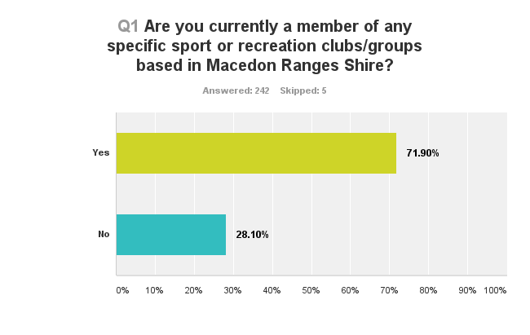

* Approximately 170 respondents identified clubs that they belong to. More than 50 individual clubs and groups were identified representing a variety of sports and activities ranging from, traditional sporting clubs, martial arts, running and cycling groups to health clubs and leisure centers.
* Tennis Clubs dominated responses with 46 individual respondents (i.e. 27% of responses) followed by members of the Wombat Mountain Bike Club which had 29 respondents (17%). The majority of tennis club respondents were from Kyneton Tennis Club (28 respondents or 16%), Macedon Tennis Club (10 respondents or 6%) and Riddells Creek (5 respondents or 3%).

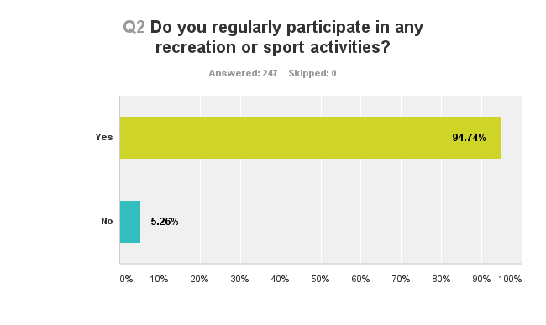

* Based on survey respondents, the top 20 activities undertaken are largely consistent with State participation trends with the following exceptions/observations:
  + Tennis appears over represented at 28.3%, compared to State average of approximately 4.2%. This may reflect the high number of respondents that identified as members of existing tennis clubs in the Shire.
  + As with tennis, Mountain Biking appears over represented at 23.9%, compared to State average of approximately 8.8% (cycling/BMX – MTB is not specifically identified). Once again, this may reflect the high number of respondents that identified as members of the Wombat MTB Club.
  + Hiking and Horse Riding/Equestrian activities appear more popular in MRSC than State averages, which reflects the character of the Shire.
  + The top 20 list include a mix of formal traditional sports and informal recreation pursuits. More people are participating in informal activities compared to traditional formal sports. This reflects State and National trends. Interestingly fishing, surf sports and skateboarding appear in the top 20 survey results, however these rank well outside the 20 most popular activities in the State.
  + Although more people are participating in informal activities, participation rates in traditional sports (e.g. Tennis, Australian Football, Basketball, Netball, Golf, Soccer and Cricket) are higher than State averages.

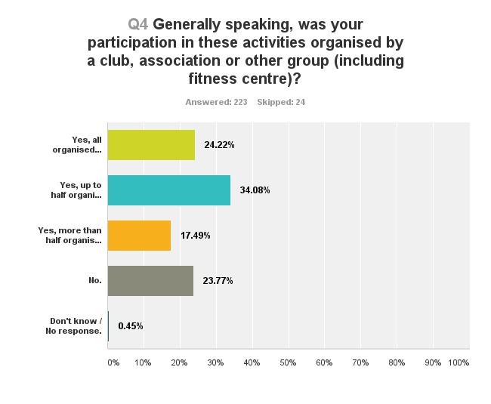

* A similar proportion of respondents either only participate in organised (24.22%) or non-organised activities (23.77%).
* However, overall for the majority of participation (57.85%) is generally not-organised by a club or group (i.e. 23.77% + 34.08% = 57.85%). This compares to 41.71% whose participation is generally organised.
* These figures highlight the importance of an equitable balance in resource allocation to support both forms of participation.

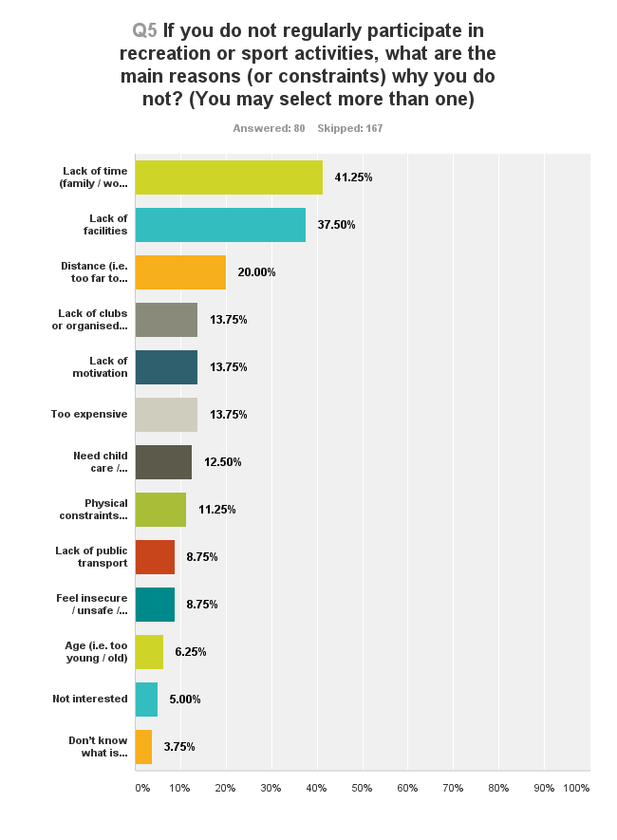

* Survey responses generally reflect common industry replies, for example lack of time, lack motivation, child care, physical constraints, age, not interested, etc. However a number of responses point to possible opportunities for Council intervention to help improve outcomes. For example, lack of facilities, lack of clubs/groups, too expensive, need for child care, public transport and perceptions of safety.
* Interestingly around 1 in 5 responses (20%) identified *distance to travel* as a barrier to participation, however this largely reflects the geographic character of the Shire.

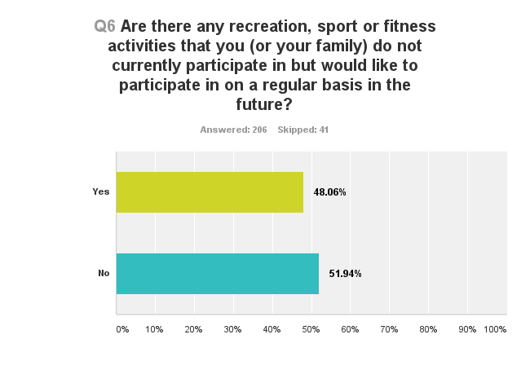

* Just under half of all respondents indicated that they would like to participate in new or additional activities.
* Informal activities dominate the most common responses, particularly walking, cycling, swimming and aerobics/fitness.
* Mountain biking and tennis also rank highly, potentially influenced by the large proportion of members responding to the survey.
* Aside from tennis, other traditional club based sports do not appear in the 10 most popular responses.

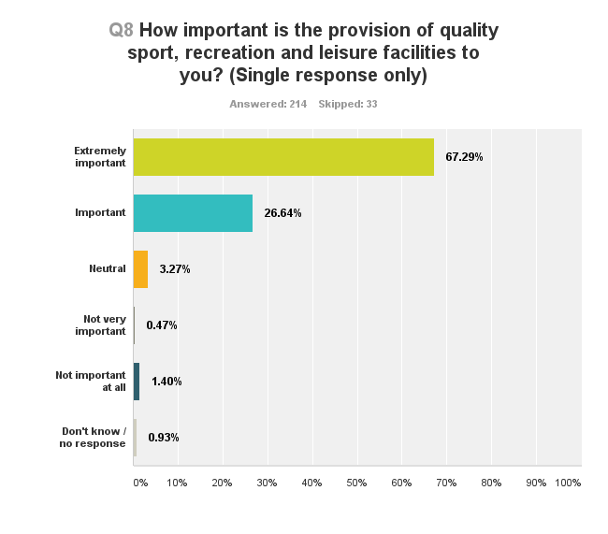

* The overwhelming majority of respondents (93.53%) identified the provision of quality sport, recreation and leisure facilities as *extremely important* or *important*.
* Less than 2% of respondents suggested the provision of quality facilities as *not very important* or *not important at all*.

**Q9: How would you rate the performance of Council over the past 3 years in the following areas?**

* The majority of respondents (64%) rated provision as good or better. However, approximately one quarter (26%) rated provision as poor or very poor.
* The majority of respondents (61%) rated sports field and court maintenance as good or better. However, almost one quarter (22%) rated maintenance as poor or very poor.
* A relatively high proportion of respondents (17%) did not rate performance.
* Half of all respondents (50%) rated club room and building maintenance as good or better. However, over one quarter (26%) rated club room and building maintenance as poor or very poor.
* Almost one quarter (23%) did not rate performance.
* The majority of respondents (44%) rated coordination and allocation of sport facilities as good or better. However, almost one quarter (24%) rated performance as poor or very poor.
* A larger proportion of respondents (32%) did not rate performance.
* 38% of respondents rated Council performance as good or better in developing new facilities, however the majority (49%) rated Council performance as poor or very poor.
* A similar proportion of respondents suggested Council performance in improving existing facilities (and parks) was good or very good (48%), compared to poor or very poor (41%).
* Half of all respondents (50%) rated Council performance in providing a diverse range of facilities as good or very good. Whereas 38% rated performance as poor or very poor.
* 45% of respondents suggested Council performance in supporting local clubs and groups as good or better, however slightly over one third (36%) rated performance as poor or very poor.
* Slightly more people rated Council performance in providing or supporting programs and participation as good or very good (44%) compared to poor or very poor (39%).
* An equal proportion of respondents (40%) rated Council performance in meeting their needs as good or better, compared to poor or very poor.
* A relatively high proportion (19%) failed to rate Council performance in meeting needs.
* A similar proportion of respondents rated Council performance in providing information/promotion as good or better (45%), compared to poor or very poor (42%).

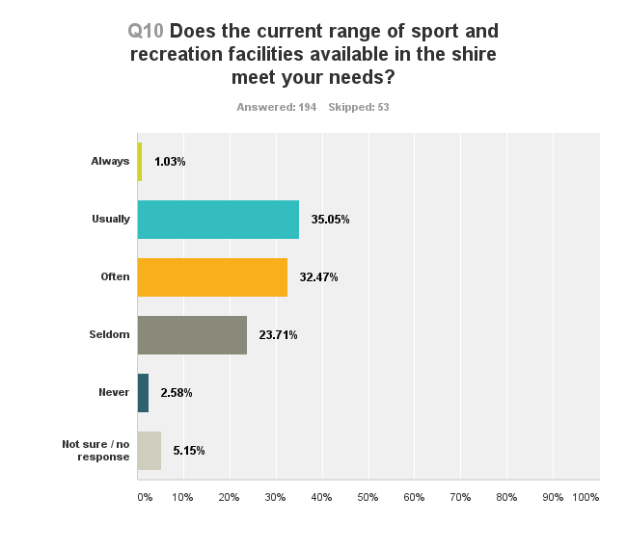

* Existing facilities are generally meeting the needs of survey respondents.
* The majority of respondents (68.55%) indicated that existing facilities *often, usually or always* meet their needs.
* However, over one quarter (26.29%) suggested that existing facilities *seldom* or *never* meet their needs.

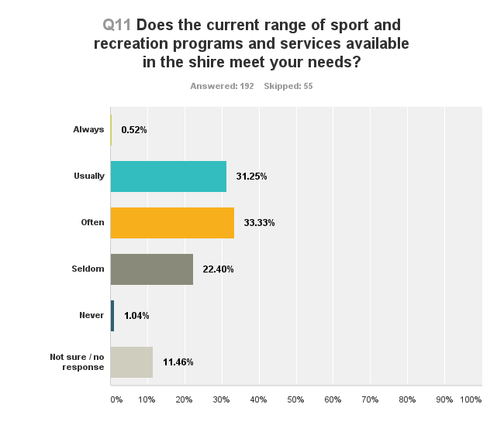

* Existing program and services are generally meeting the needs of survey respondents.
* The majority of respondents (65.1%) indicated that existing programs and services *often, usually or always* meet their needs.
* However, approximately one quarter (23.08%) suggested that existing facilities *seldom* or *never* meet their needs.

**Question 12: If you had to nominate the three main priorities for Council in relation to current and future sport and recreation facilities what would they be?**

**Priority 1:**

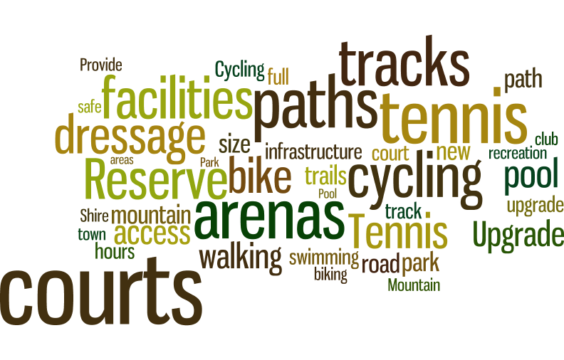

**Priority 2:**

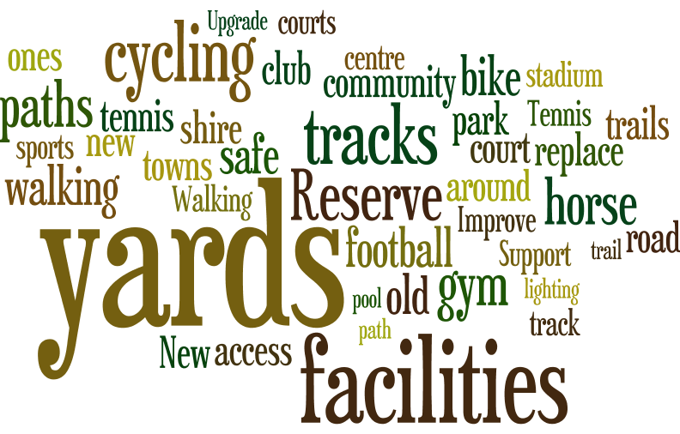

**Priority 3:**

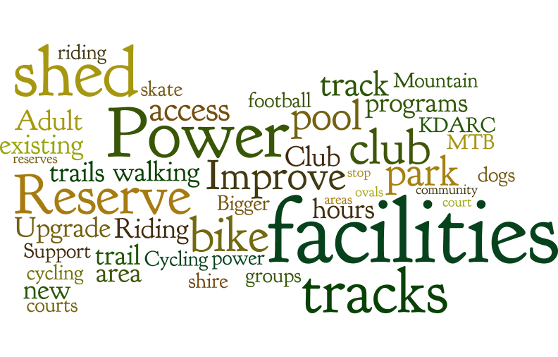

* Common sport and recreation facility priorities identified by survey respondents include:
  + Tennis courts – upgrade and new.
  + Cycling facilities, including mountain biking.
  + Walking paths, tracks and trails.
  + Dressage arenas, holding yards and associated equestrian facilities/infrastructure (including power to shed in Rollinson Reserve).
  + New and improved sport and recreation facilities.
  + Support aquatic and gymnasium facilities.
  + Extend hours of access to existing facilities.

**Q13: If you had to nominate the three main priorities for Council in relation to current and future sport and recreation programs and services what would they be?**

**Priority 1:**

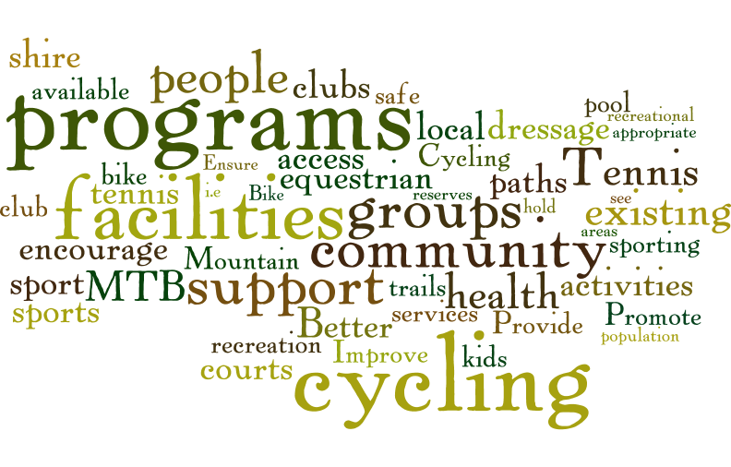

**Priority 2:**

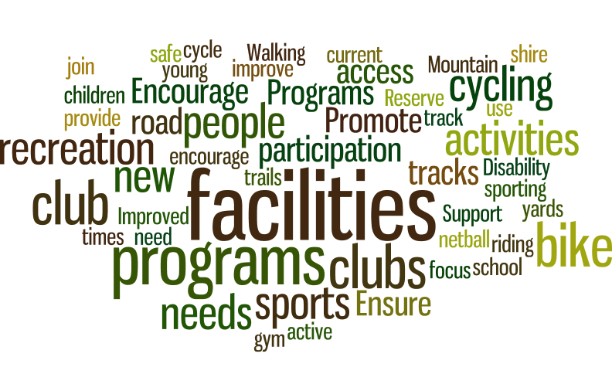

**Priority 3:**

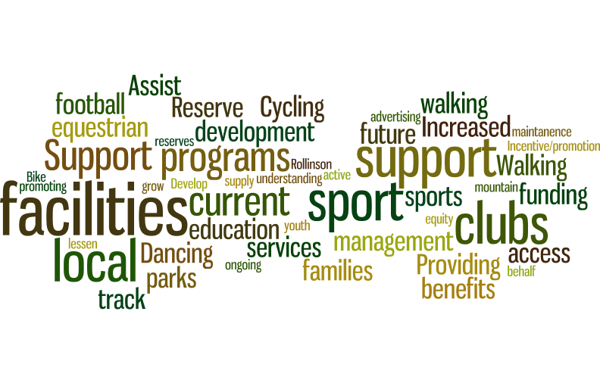

* Common priorities for programs and services identified by survey respondents include:
  + Initiatives to support local clubs and groups (including cycling, mountain biking and dressage/equestrian).
  + Encourage participation with a focus on health outcomes for all age groups.
  + Provide access to facilities (including access to tennis courts).
  + Education and promotion.
  + Walking and cycling initiatives, including road safety and education program.
  + Partner with schools to promote cycling.
  + Increase operating hours of facilities to increase access.
  + Funding support.
  + Activation of parks and reserves – host participation events/activities.
* Suggested roles for Council in supporting physical activity participation are varied, ranging from physical infrastructure, club development/support, marketing/promotion and direct service provision.
* Improving walking paths, tracks and trails was the most common response.
* The following most common role-themes suggested were:
  + Walking paths and trails.
  + Improve existing facilities.
  + Club and Reserve Committee development and support.
  + Maintain existing facilities.
  + Develop new facilities.
  + Marketing and promotion.
  + Establish new clubs/groups.
  + Direct service provision.
  + Financial subsidies.

**Q15: Do you have any suggestions for how Council may encourage residents to be more physically active, more often?**

A total of 98 people provided comments and suggestions in response to this question. Answers have been summarised into the following common themes:

* There is strong support for ongoing investment in walking and cycling infrastructure in order to support and encourage physical activity participation.
* There also appears to be strong support for Council in awareness/education and promotion of physical activity participation opportunities (and benefits), as well as hosting special events and activities aimed at encouraging participation.
* A range of other potential areas for Council action are identified in the graph above.

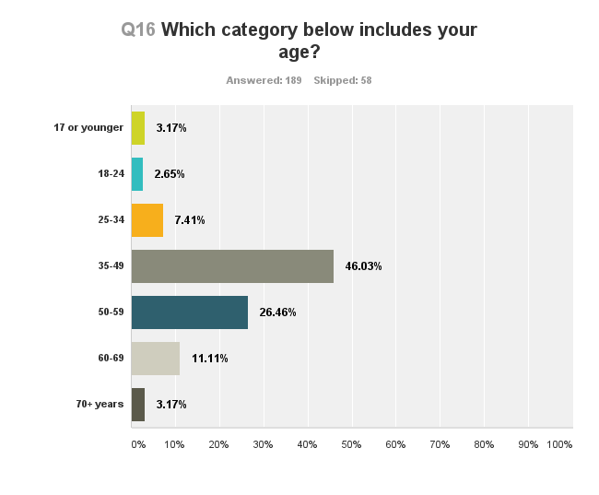

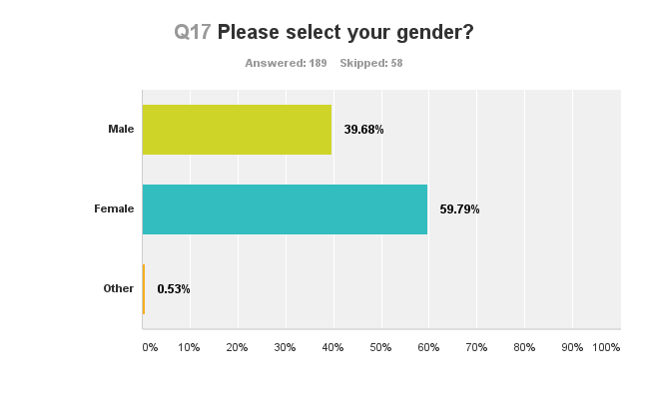

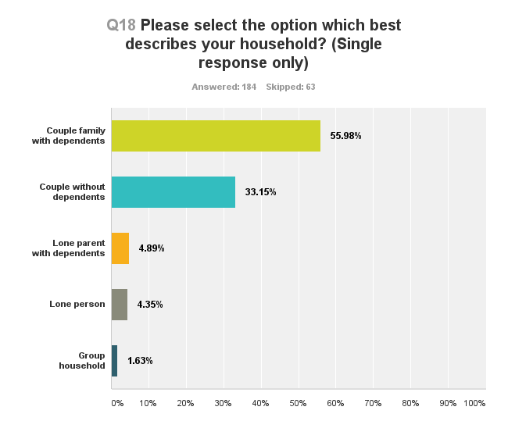

Club Survey results

Survey conducted February/March 2016.

Total respondents = 48.

**Q1: Name of your club or group:** *(listed in no specifc order, numbers asigned for referencing only, not all respondents answered alll questions)*

**Woodend:**

1. Woodend District Netball Club
2. Woodend Little athletics
3. Woodend Cricket Club
4. Woodend Hesket Football Netball Club
5. Woodend Bowling Club Inc
6. Woodend Hawks Junior Football Netball Club

**Kyneton:**

1. Kyneton Badminton Club
2. Kyneton & District Tennis Club
3. Kyneton & District Adult Riding Club
4. Kyneton Croquet Club
5. Kyneton Badminton Association
6. Kyneton Pony Club
7. Kyneton Golf Club
8. Kyneton Car Club Inc.
9. Kyneton Netball Association

**Macedon:**

1. Macedon Cricket Club
2. Macedon Football Netball Club
3. Macedon Pony Club
4. Macedon Ranges Futsal*
5. Macedon Ranges Squash Club*
6. Macedon Ranges Running Club*

* Shire wide groups

**Riddells Creek:**

1. Riddell Creek Tennis Club Inc
2. Riddells Creek Junior Mixed Basketball Association
3. Riddell Football Netball Club
4. 1st Riddells Creek Scout Group
5. Riddell cricket club Inc.
6. Riddells Creek Junior Mixed Basketball Association

**Lancefield:**

1. Lancefield Football Neball Club Inc
2. Lancefield Bowling Club Inc
3. Lancefield Park Recreation Reserve

**Romsey:**

1. Romsey Bowling Club
2. Romsey Golf Club
3. Romsey Cricket Club

**Gisborne:**

1. Gisborne Golf Club
2. Gisborne Cricket Club
3. Macedon Ranges Croquet Club

**Others:**

1. Mount Macedon Golf Club
2. Jane's Gentle Exercise
3. Malmsbury Cricket Club

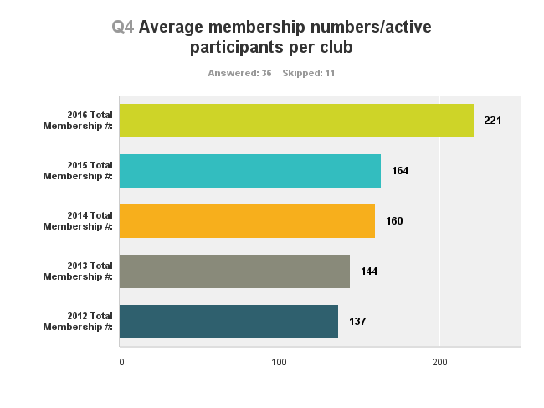

* The average club membership of survey respondents has increased by approximately 61% since 2012.
* Significant increases appear to have occurred most recently, that is, average membership jumping from 164 in 2015 to 221 in 2016 (i.e. approximately 35% increase in one year).

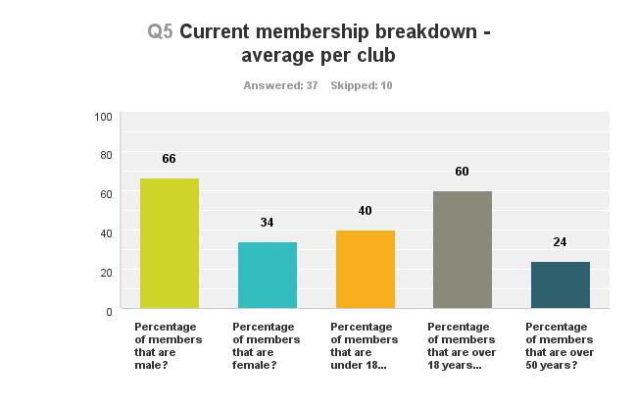

* Males dominate club membership by approximately 2 to 1.
* Clubs cater for a range of age groups, including those under 18 years (40%) and over 50’s (24%).

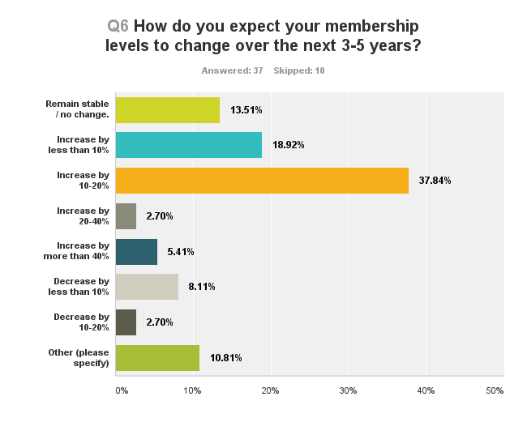

* Over half of all clubs (i.e. 57%) expect membership to increase by up to 20% over the next 3-5 years. In total, almost 65% of all clubs expect membership to increase, with 5% expecting increases of more than 40%.
* Only 13% expect membership to remain stable. A further 11% expect membership to decline.
* Approximately three quarters of respondents attribute expected club membership increases to pro-active club initiatives to recruit.
* Over half of clubs expect membership to increase as a direct result of population growth.
* The results reflect the impact of internal and external influences on club membership. Internal influences include club initiatives (74%), quality coaches/administration (45%) and positive competition results (45%).
* External influences include population growth (51%) as well as Council and peak body initiatives, such as quality of facilities (43%), developing new facilities (23%), increasing popularity of the sport (31%) and State Association initiatives (31%) respectively.

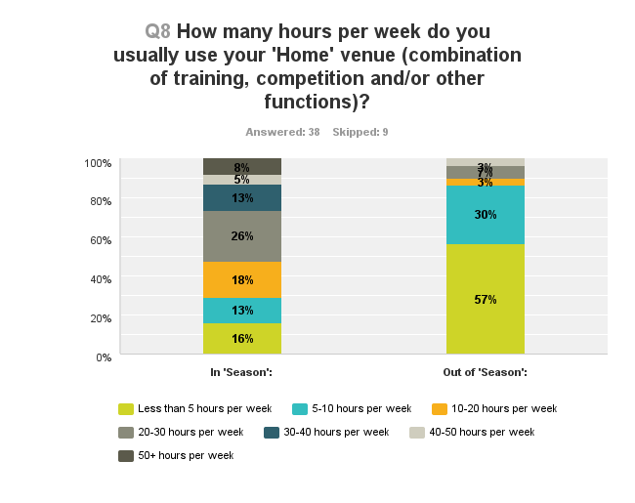

* In season:
  + The majority of clubs (26%) use their ‘home’ venue 20-30 hours per week.
  + A further 26% use their facilities more than 30 hours per week, with 13% using facilities more than 40 hours per week.
  + The results highlight quite a range in the level of use by clubs in-season, ranging from less than 5 hours per week to more than 50 hours per week.
* Out of season:
  + The vast majority of club (57%) use their facilities less than 5 hours per week out of season. However, almost one-third of clubs (30%) still utilise facilities 5-10 hours per week.
  + A small proportion of clubs (13%) continue to use facilities more than 10 hours per week.
* The results highlight the challenges associated with shared use of facilities and potential implications from seasonal-creep.

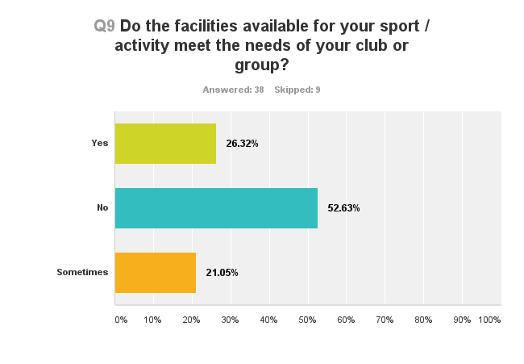

* More than half of clubs (53%) indicted that existing facilities do not meet their needs.
* A further 21% indicated that facilities only ‘sometimes’ meet their needs. Therefore almost three quarters (74%) of clubs indicated that facilities are not meeting their needs.
* Only 1 in 4 clubs indicated that facilities are meeting their needs.

**Q10: How would you rate the performance of Council over the past 3 years in delivering the following services?**

* Almost three quarters (72%) of clubs rated Council performance as good or better.
* Approximately 17% rated performance as poor or very poor.
* A large proportion of respondents (38%) did not rate performance – not all groups utilise sports grounds.
* Slightly over half (51%) rated performance as good or better.
* Around 10% rated performance as poor or very poor.
* A very large proportion of respondents (70%) did not rate performance – not all groups utilise outdoor courts.
* Only 16% rated performance as good or better. A similar proportion (14%) rated performance as poor or very poor.
* A large proportion of respondents (38%) did not rate performance.
* Only 30% rated performance as good or better.
* Almost one third (32%) rated performance as poor or very poor.
* *Pavilion and building maintenance* and *developing new facilities* received the equal highest proportion of ‘very poor’ ratings (16%) for all categories.
* A large proportion of respondents (32%) did not rate performance.
* A similar proportion of respondents rated performance as good or better (35%); and poor or very poor (32%).
* *Pavilion and building maintenance* and *developing new facilities* received the equal highest proportion of ‘very poor’ ratings (16%) for all categories.
* Whilst the majority of respondents rated performance as good or better (58%), this item received the second highest poor rating (33%) for all categories.
* Over one third of clubs rated Council performance as poor or very poor (39%).
* Over half (51%) rated performance good or better, however a high proportion (38%) also rated performance as poor or very poor.
* More clubs rated performance as poor or very poor (41%) compared to good or better (38%).
* Providing club development and management support received the highest poor rating (35%) compared to all other categories. Over 43% of respondents rated performance as poor or very poor.
* Less than one third (30%) rated performance as good or better.
* A similar proportion of respondents rated performance as good or better (35%); and poor or very poor (38%).
* A similar proportion of respondents rated performance as good or better (46%); and poor or very poor (43%). The results suggest that Council is only meeting the needs of approximately half of current clubs/groups.
* Whilst Council may only be meeting needs of around half of individual club/groups (refer graph above), 46% rated performance as good or better in terms of meeting the needs of their sport/activity across the Shire as a whole. Compared to 30% rating performance as poor or very poor.

**Q11: What are the biggest challenges facing your club?**

**Challenge 1:**

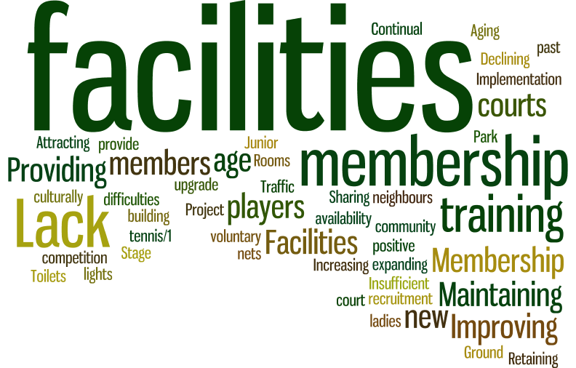

**Challenge 2:**

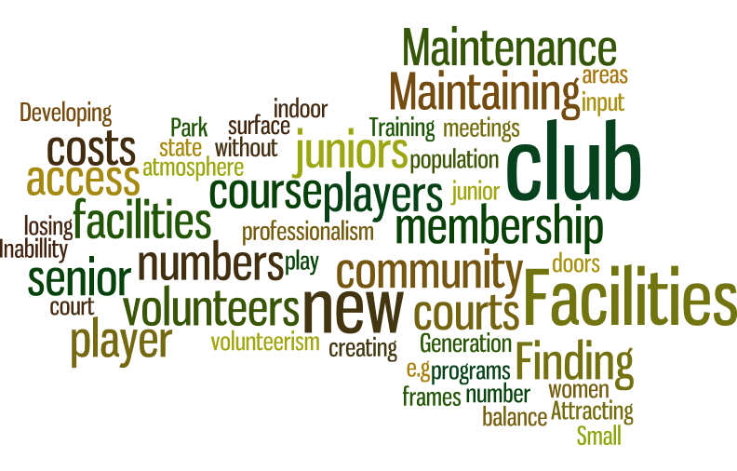

**Challenge 3:**

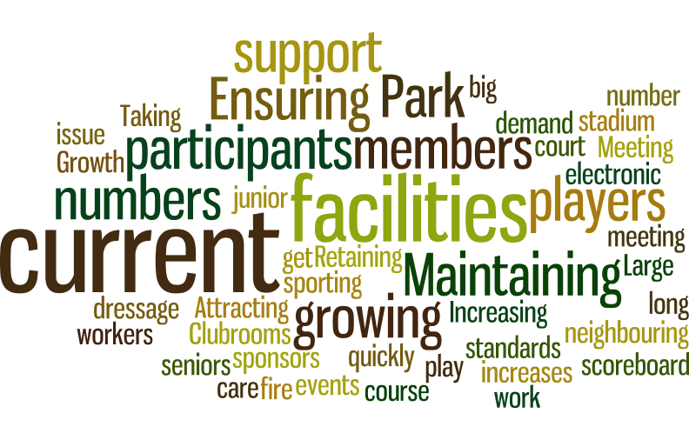

The word maps highlight the most common responses. Dominate responses are shown in bigger type. Analysis of the results highlight the following key themes/challenges reported by individual clubs/groups:

* Facilities – maintenance, management and renewal as well as providing adequate facilities to meet demands. Increasing facility standard expectations/requirements.
* Membership – recruitment, retention and growing membership.
* Volunteers – recruitment, retention and training, including coaches.
* Catering for growing demand – juniors and seniors.
* Club management – costs and fundraising, as well as increasing professionalism of club administration expectations/requirements.

**Q12: How would you like Council to assist you in addressing these challenges and supporting your club / group?**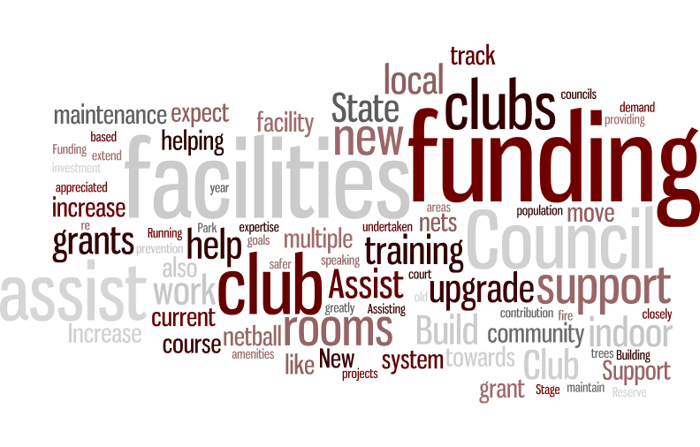

* Key themes for assistance include:
  + Facility development and funding.
  + Club development and support assistance.
  + Facility maintenance assistance.
  + Increase grants and funding.

**Q13: Thinking about the entire shire, what do you think should be the top three priorities for sport and recreation facilities over the next ten years?**

**Priority 1:**

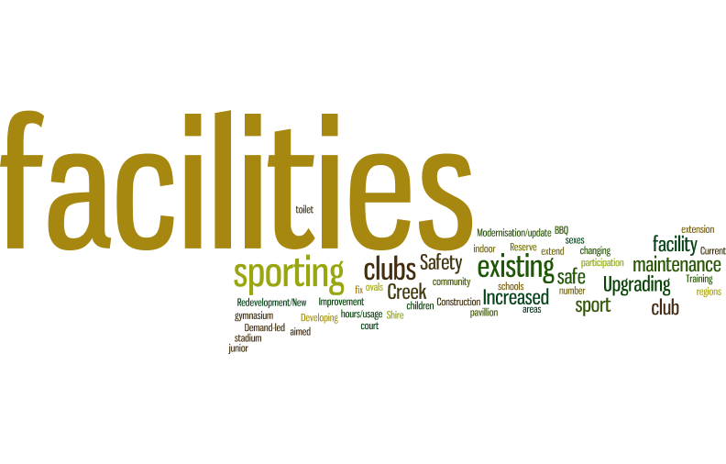

**Priority 2:**

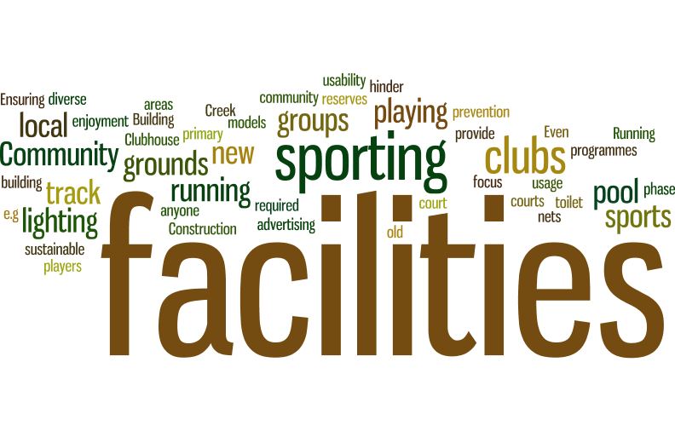

**Priority 3:**

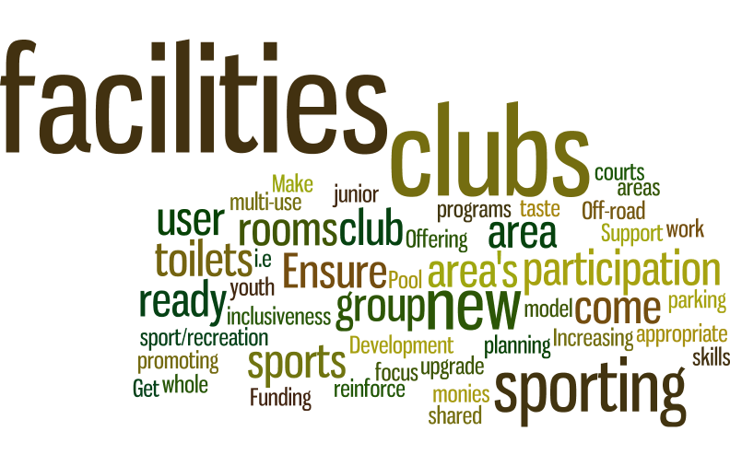

Priorities for sport and recreation facilities include:

* Develop new facilities – including tennis courts, tracks and trails.
* Upgrade / renew existing facilities – including lighting and club rooms.
* Support increased maintenance of existing facilities.
* Multi-use facilities to meet growing demands and encourage participation.

Q14: Thinking about the entire shire, what do you think should be the top three priorities for sport and recreation programs and services over the next ten years?

**Priority 1:**

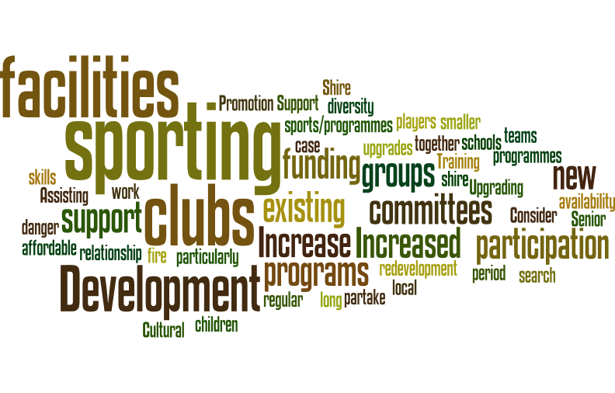

**Priority 2:**

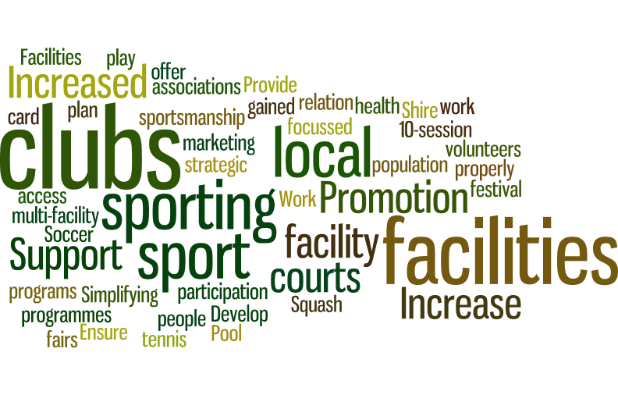

**Priority 3:**

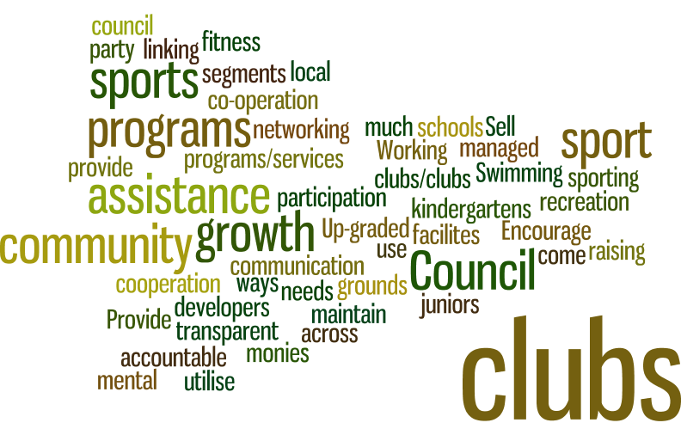

Priorities for sport and recreation programs and services include:

* Club development and support.
* Facility improvement programs / services.
* Initiatives to support increasing participation.
* Funding programs and assistance.
* Promotion and marketing – increasing awareness of existing opportunities.
* Transparent processes and accountability.

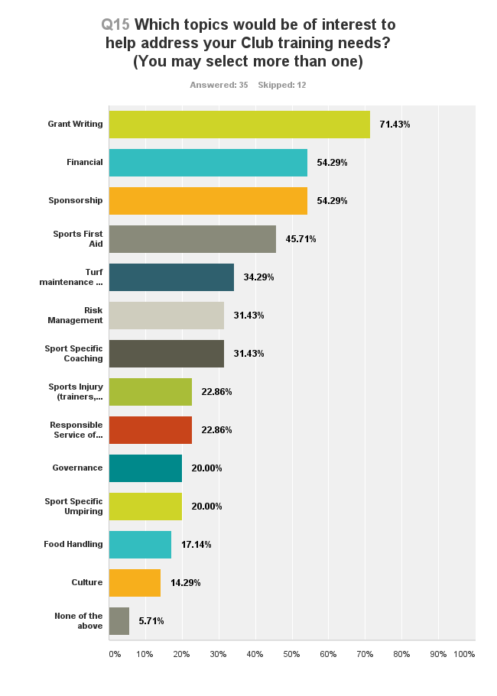

* Clubs are interested in a range of training and development topics, particularly grant writing, financial management, sponsorship, first aid, etc.

Q16: Additional comments.

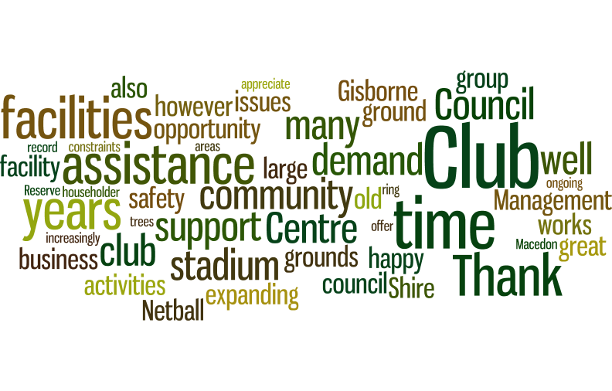

* Key themes include:
  + Clubs need assistance to cater for growing participation demands.
  + Additional facilities are required to cater for the growing population.
  + Facility planning assistance, funding and support.
  + Support the community to support themselves.
  + Recognise and thanks clubs for the work that they do in the community.
  + Additional indoor facilities – multi-use stadium required.

Summary of Submissions on Draft Strategy (2017)

|  |  |  |  |  |
| --- | --- | --- | --- | --- |
| **DRAFT LEISURE STRATEGY 2017-2027** | | | | |
| **NO.** | **CLUB/ORGANISATION** | **SUBMISSION COMMENTS** | **CONSIDERATION IN REPORT** | **RESPONSE TO SUBMISSION** |
| 1 | Resident | Wishes to explore the development of a dog park in the Shire. | Comment added at 1.1.2.  Support for Domestic Animal Management Plan 2017-2021. | The Leisure Strategy supports a direction in Council's latest Domestic Animal Management Plan 2017-2021, which recommends an investigation into the feasibility of introducing an Order which identifies dog on and off lead areas in the Shire. The investigation is to include regulatory requirements and be completed in 2018/2019. |
| 2 | Council Meeting Resolution 21-09-2016 | That Council work with the user groups of Dixon Field, including the Croquet Club, as to a Master Plan for the area addressing future expansion requirements to service the growing needs across a wide population base and diverse sporting interest'. | Revised action 4.2.1. | As a high priority, development of a Master Plan for Dixon Field (Gisborne) has been included in the Leisure Strategy. This will address future facility and playing field requirements to service the needs of a growing population with diverse sporting interests. Includes working with user groups of tennis, croquet and soccer. |
| 3 | Tylden Hall Committee | Tylden multi-purpose court not included in the Strategy.  Proposes additional facilities at Tylden. | No change required. Refer to current action in tennis summary in section 6.1. | The Leisure Strategy supports innovative re-use of former tennis club facilities in smaller settlements (including Darraweit Guim and Tylden) to encourage broader community use, recreational appeal and sustainable management. |
| 4 | Macedon Ranges Croquet Club | Croquet caters for ageing population and those with a disability.  The sport promotes equity, inclusion and social connection.  Club agrees with maintaining/improving assets and has identified disabled toilets, hand rails etc placed around the facility to cater for all abilities. | Revised croquet summary in section 6.1.  Issues to be considered as part of Dixon Field Master Plan (see action 4.2.1). | As a high priority, development of a Master Plan for Dixon Field (Gisborne) has been included in the Leisure Strategy. This will address future facility and playing field requirements to service the needs of a growing population with diverse sporting interests. The proposed Master Plan will be used to guide infrastructure and facility improvement priorities at Dixon Field, including priorities for croquet facilities. |
| 5 | Resident | Requesting improved maintenance of tracks and footpaths around Jacksons Creek and Botanic Gardens, Gisborne to ensure accessibility in all weather conditions. Requesting additional walking/cycling paths in New Gisborne. | No change required. Refer to Walking & Cycling Strategy and Shire Wide Footpath Plan. Issues raised referred to Council Maintenance Department for rectification. | The Leisure Strategy is intended to be high-level strategic document which is supported by a number of specific plans. This includes the Walking & Cycling Strategy and Shire Wide Footpath Plan which guide specific improvement priorities, including new path or trail connections.   A key action of the current Council Plan (2017-2021) is the Year-One investment of $1.1 million in planning, renewing and building new footpaths and cycling paths to improve access and community connections across the Shire.   The issues raised regarding maintenance/drainage along Jacksons Creek Reserve/Botanic Gardens have been referred to Council's Maintenance Department to rectify. |
| 6 | Resident | Consider including horse riding trails/tracks in the Walking & Cycling Strategy. Horseriding caters for predominantly female participation.  Indicates that there are a large number of recreational (non-club based) horse riders in the Shire. | Revised action 4.2.8. Equestrian is to be considered in the Macedon Ranges Shared Trail Feasibility Study in 2017/18. | The Leisure Strategy is intended to be a high-level strategic document which is supported by a number of specific plans. This includes the Playground Plan and Aquatic Facilities Plan, etc. The Leisure Strategy recommends that Council develop an Equestrian Facilities Plan in conjunction with equine clubs, groups and associations. The Plan will determine future improvement needs and outline opportunities to establish safe trail riding locations (in collaboration with other land management agencies) to increase participation and sustainability of equestrian activities in the Shire.    The Shire is also undertaking a Macedon Ranges Shared Trail Feasibility Study later in 2017/18 which will also consider options for shared trails in the region, including possible equestrian use. |
| 7 | Resident | Requesting bike tracks be developed in Lancefield. | No change required.  Refer to current action 1.1.1. | The Leisure Strategy supports progressive implementation of the Shire's existing Walking & Cycling Strategy to guide trail development and infrastructure priorities across the Shire. Council also has a Shire Wide Footpath Plan which guides township specific infrastructure priorities and gaps.   A key action of the current Council Plan (2017-2021) is the Year-One investment of $1.1 million in planning, renewing and building new footpaths and cycling paths to improve access and community connections across the Shire. |
| 8 | Resident | Suggestions for shade sails and toilet block at the Lancefield Park playground. | No change required.  Refer to current action in Lancefield summary in section 6.1. | The potential for installation of shade sails and development of toilet facilities in Lancefield Park will be considered as part of the review of the 2011 Reserve Master Plan. The Leisure Strategy recommends the Reserve Committee of Management review the previous Master Plan to update improvement priorities and respond to the Shire's Open Space Strategy, which suggests consolidating elements of the north east corner of the Reserve and design as a district/social family recreation space. |
| 9 | Resident | Wishes to see emphasis on safe off road horse riding in Kyneton and expresses concern over float access and sharing paths with motorbikes (Wombat/Cobaw). Disappointed to hear horses are being prevented access to Bald Hill Reserve.  Create more spaces for horses. | Revised action 4.2.8. Equestrian is to be considered in the Macedon Ranges Shared Trail Feasibility Study in 2017/18. | The Leisure Strategy is intended to be a high-level strategic document which is supported by a number of specific plans. This includes the Playground Plan and Aquatic Facilities Plan, etc. The Leisure Strategy recommends that Council develop an Equestrian Facilities Plan in conjunction with equine clubs, groups and associations. The Plan will determine future improvement needs and outline opportunities to establish safe trail riding locations (in collaboration with other land management agencies) to increase participation and sustainability of equestrian activities in the Shire.    The Shire is also undertaking a Macedon Ranges Shared Trail Feasibility Study later in 2017/18 which will also consider options for shared trails in the region, including possible equestrian use. |
| 10 | Resident | Identified inaccuracy of data regarding Romsey Golf Course. Requests that Council support the Golf Club in establishing their own club house facility.  Inaccuracy of information regarding Romsey Park Committee, Romsey Park Management Committee and Romsey Sport Association. | Revised Golf summary in section 6.1. | The Leisure Strategy has been altered to acknowledge Romsey Golf Course as an 18-hole course (utilising some shared greens). However, the Leisure Strategy supports Council's existing Open Space Strategy (2013, R4) which recommends investigating "options to reduce the Romsey Golf Course to nine holes and make the remaining land available for expansion of sport and open space facilities". This is considered a long-term direction and important to ensuring adequate land to support future community needs.   The Leisure Strategy recommends that no additional golf courses are to be developed in the Shire, with the onus remaining on local clubs to be self-sufficient and sustainable in their own right. Clubs are encouraged to seek development support via Golf Victoria, to outline priorities and opportunities for collaboration, cross-promotion and increasing participation across the region.   Clubs can also apply to Council’s existing grants and funding programs for minor capital works and improvement initiatives on a case by case basis. It is also recommended that the Romsey Golf Club continue to work with the Romsey Sports Association to resolve local clubhouse/accommodation issues. |
| 11 | Gisborne Soccer Club | Stated that the synthetic pitch at Dixon Field should be of immediate priority rather than 'very long term'.  States that lights will be required at outer pitch.  Comments around high levels of participation and the club not coping with usage loads. Suggesting by 2027 club will need four new pitches to cater for demand.  Comments around need to upgrade old pavilion and change rooms as per development plan. | Revised football (soccer) summary in section 6.1. Note: A synthetic pitch has not been included in costings - subject to Master Plan outcomes 4.2.1. | As a high priority, development of a Master Plan for Dixon Field (Gisborne) has been included in the Leisure Strategy. This will address future facility and playing field requirements to service the needs of a growing population with diverse sporting interests. The proposed Master Plan will be used to guide infrastructure and facility improvement priorities at Dixon Field, including potential provision of a synthetic pitch. |
| 12 | Macedon Cricket Club | Inclusion of Tony Clarke Reserve cricket nets renewal to be included in the strategy. | Revised cricket summary in section 6.1. | The Leisure Strategy recommends that Council undertake an audit of current cricket practice nets to determine priority for a program of staged upgrade/renewal throughout the Shire. Facilities at Tony Clarke Reserve will be considered in the audit process and improvement works scheduled accordingly. |
| 13 | Romsey Golf Club | Incorrect information regarding participation numbers and layout of course. | Revised Golf summary in section 6.1. | The Leisure Strategy has been altered to acknowledge Romsey Golf Course as an 18-hole course (utilising some shared greens). However, the Leisure Strategy supports Council's existing Open Space Strategy (2013, R4) which recommends investigating "options to reduce the Romsey Golf Course to nine holes and make the remaining land available for expansion of sport and open space facilities". This is considered a long-term direction and important to ensuring adequate land to support future community needs.   The Leisure Strategy recommends that no additional golf courses are to be developed in the Shire, with the onus remaining on local clubs to be self-sufficient and sustainable in their own right. Clubs are encouraged to seek development support via Golf Victoria, to outline priorities and opportunities for collaboration, cross-promotion and increasing participation across the region.   Clubs can also apply to Council’s existing grants and funding programs for minor capital works and improvement initiatives on a case by case basis. It is also recommended that the Romsey Golf Club continue to work with the Romsey Sports Association to resolve local clubhouse/accommodation issues. |
| 14 | Wombat MTB Club | Need to update information as progress has occurred regarding signage.  Council to play a role in working with DELWP and forest managers regarding access to areas and formalisation of tracks.  Support for off road cycling tracks.  Bring forward review of Walking & Cycling strategy.  Consolidation of different cycling websites.  Development of an all-weather asphalt pump track in Woodend. | Revised action 1.1.3.  Revised action 4.2.10. | The Leisure Strategy has been updated in consideration of the latest information included in the submission (e.g. signage works). A new action recommends Council support initiatives to promote and advocate for the Shire as a Mountain Bike (MTB) destination, including working with other land managers as appropriate.   The Leisure Strategy also recommends that the scheduled review of the Walking & Cycling Strategy (in 2019, subject to available funding) considers options to broaden the project scope to provide greater consideration of cycling facilities, needs and infrastructure on non-Council land, in particular MTB trails. |
| 15 | Resident | More recreation infrastructure in Romsey - playground and pool. | No change required.  Refer to Open Space Strategy, Aquatic Strategy and swimming summary in section 6.1. | The community's aspirations for additional recreation infrastructure in Romsey are acknowledged. Council's existing Open Space Strategy recommends that Council continue to work with the community and GRAAP (Greater Romsey All Abilities Park Inc.) to secure the former Romsey Primary School site for the purpose of an all abilities park. When developed, the park will provide a high quality play space for the region as requested in your submission.   Council's Aquatic Strategy considered the provision of an indoor pool in Romsey, however the Leisure Strategy supports the proposed action to "review the Council's capacity to fund an aquatic centre in Romsey in 2027". |
| 16 | Macedon Ranges Basketball Association | Requesting review of information regarding number of existing courts, ratios and ability to access Braemar.  Requests Sports Hub Feasibility Study findings be incorporated into Leisure Strategy. Support for the Sports Hub proposal. | Revised basketball summary in section 6.1.  Refer to Sports Hub Feasibility Study (when finalised). | The submission has been reviewed and information updated in the Leisure Strategy where appropriate, in particular any reference to indoor sports as 'minor' has been removed.   The use of ratio's remain a relevant planning guide, however more detailed investigation of the indoor court needs of the community is required prior to confirming future facility priorities. In 2017, Council commenced a Sports Hub Feasibility Study in order to complete a detailed assessment of the indoor court needs of the community, including investigating the possible establishment of a single multi-court venue. The Leisure Strategy recommends that Council complete the Sports Hub Feasibility Study to guide future indoor court provision in the Shire. |
| 17 | Resident | Support for an Aquatic Centre in Romsey as Gisborne Aquatic Centre is heavily used and will be more so as the population grows. | No change required.  Refer to Aquatic Strategy. | The community's aspirations for an indoor aquatic facility in Romsey are acknowledged. However, as the development is not within Council's current capacity, the Leisure Strategy supports the existing action in the Shire's Aquatic Strategy to "review the Council's capacity to fund an aquatic centre in Romsey in 2027". |
| 18 | Resident and member of Hanging Rock Tennis Club | Supportive of retaining tennis at Hanging Rock. | Revised tennis summary in section 6.1. | The Leisure Strategy has been amended to remove any reference to possible 'mergers' with other tennis clubs. Rather, smaller clubs will be supported to explore options with other clubs (as required) in order to support ongoing participation in competition tennis. |
| 19 | Resident | Inequity of funds being spent on males vs females in relation to expenditure on male dominated sports of AFL and cricket.  Ratios are incorrect for New Gisborne Ovals.  Incorrect assumptions and ratios used for indoor sports. Sports Hub feasibility outcomes to be included into Leisure Strategy.  No consideration for ageing population or people with a disability. | No changes required.  Refer to Sports Hub Feasibility Study (when finalised) and draft New Gisborne Regional Sports Fields Feasibility Study and Master Plan. | Council is undertaking a program of facility redevelopments across the Shire to address female access to change room facilities and provision of umpires facilities. Council has also invested significantly in tennis facility upgrades which have higher female participations levels. In isolation, the figures provided do indicate a higher spend on traditional male sporting facilities, however the majority of these works are to develop these facilities as female friendly and to cope with the increase in demand by female players. Most of the investment in football and cricket also relates to a one-off major project (New Gisborne Regional Sports Fields) and follows a significant investment made in the last few years with the Macedon Ranges Regional Netball Complex and Stadium.   There is a considerable asset renewal gap that requires Council to maintain existing assets to a certain standard, with historically the oldest facilities requiring the most improvement being football change rooms. The increase in female participation in AFL is driving the need to upgrade facilities to the required standards.   Both the initial and draft consultation phases provided a significant number of opportunity for groups/individuals/organisations within the Shire to have their say, in which a copy of the consultation methods used will form a part of the Council report.   Whilst the Leisure Strategy will be completed prior to the completion of the Sports Hub Feasibility Study, the Study has been informed by the general principles of the draft Leisure Strategy. |
| 20 | Stanley Park Committee of Management. | Maintain Stanley Park as a bushland reserve instead of a recreation reserve. | No change required.  Refer to Open Space Strategy. | The Leisure Strategy supports the current recommendation in Council's Open Space Strategy to "consider the following in line with the draft masterplan for Stanley Park:  - Protect and enhance the park's environmental values; and;  - Interpretation elements that promote key cultural and environmental sites in the area".  Other detailed issues raised in the submission should be considered as part of any review of the Management Plan for the site by the Committee of Management. |
| 21 | Macedon Ranges Tennis Association. | Supportive of Leisure Strategy directions for tennis with some inclusions. | Revised actions 3.1.4, 3.2.4 and 4.2.2. Deleted action 3.1.11.  Revised tennis summary in section 6.1. | As the draft report contained a number of recommendations related to tennis, the final Leisure Strategy has been refined to consolidate tennis recommendations under the development of a specific *Tennis Facilities Plan*. The Plan will include an audit of existing tennis court conditions and surrounds at Macedon, South Gisborne, New Gisborne, Romsey and Lancefield to determine the scope of works required to ensure compliance and renewal requirements in conjunction with tenant clubs, and to support improvement initiatives as required subject to available funding.   The Leisure Strategy has also been altered to remove any reference to possible 'mergers' with other tennis clubs. Rather, smaller clubs will be supported to explore options with other clubs (as required) in order to support ongoing participation in competition tennis.   The Leisure Strategy has also been modified to remove the draft recommendation which encouraged clubs to have at least one court available at all times for casual community use. This has been replaced with a new recommendation to encourage clubs to support Tennis Victoria’s new online court booking system (‘Book a Court’) which enables access for non-members whilst providing income and security for the home club.   All other recommendations remain the same. |
| 22 | Macedon Tennis Club | Supportive of Leisure Strategy directions for tennis with some inclusions/clarification re timing. | Revised actions 3.1.4, 3.2.4 and 4.2.2. Deleted action 3.1.11.  Revised tennis summary in section 6.1. | As the draft report contained a number of recommendations related to tennis, the final Leisure Strategy has been refined to consolidate tennis recommendations under the development of a specific *Tennis Facilities Plan*. The Plan will include an audit of existing tennis court conditions and surrounds at Macedon, South Gisborne, New Gisborne, Romsey and Lancefield to determine the scope of works required to ensure compliance and renewal requirements in conjunction with tenant clubs, and to support improvement initiatives as required subject to available funding.   The Leisure Strategy has also been altered to remove any reference to possible 'mergers' with other tennis clubs. Rather, smaller clubs will be supported to explore options with other clubs (as required) in order to support ongoing participation in competition tennis.   The Leisure Strategy has also been modified to remove the draft recommendation which encouraged clubs to have at least one court available at all times for casual community use. This has been replaced with a new recommendation to encourage clubs to support Tennis Victoria’s new online court booking system (‘Book a Court’) which enables access for non-members whilst providing income and security for the home club.   All other recommendations remain the same. |
| 23 | Kyneton Cricket Club | Requesting access Showgrounds Oval 1 on Saturday mornings currently used by Little Athletics.  Supportive of pitch at Barkly Square, but preference is turf.  Cover required for nets. | No change required.  Refer to cricket summary in section 6.1. | The return of cricket to Barkly Square is supported by the Leisure Strategy, and a turf pitch could be established (rather than synthetic) however this would need to be at the club's cost (capital and ongoing maintenance).   The Leisure Strategy also recommends undertaking a program of staged/upgrade renewal of cricket practice nets throughout the Shire based on an audit of current cricket training facilities to determine overall priorities, including Kyneton.   In regards to access to Showgrounds Oval 1 on Saturday mornings, Little Athletics have been using the venue at this time for many years. However there could be potential for cricket to use the oval on Friday evenings or Sundays if required. |
| 24 | Hanging Rock Tennis Club | Keep Hanging Rock tennis at Hanging Rock. | Revised actions 3.1.4, 3.2.4 and 4.2.2. Deleted action 3.1.11.  Revised tennis summary in section 6.1. | As the draft report contained a number of recommendations related to tennis, the final Leisure Strategy has been refined to consolidate tennis recommendations under the development of a specific *Tennis Facilities Plan*. The Plan will include an audit of existing tennis court conditions and surrounds at Macedon, South Gisborne, New Gisborne, Romsey and Lancefield to determine the scope of works required to ensure compliance and renewal requirements in conjunction with tenant clubs, and to support improvement initiatives as required subject to available funding.   The Leisure Strategy has also been altered to remove any reference to possible 'mergers' with other tennis clubs. Rather, smaller clubs will be supported to explore options with other clubs (as required) in order to support ongoing participation in competition tennis. The Leisure Strategy also supports retaining access to local courts, including at Hanging Rock, for training and casual use.   The Leisure Strategy has also been modified to remove the draft recommendation which encouraged clubs to have at least one court available at all times for casual community use. This has been replaced with a new recommendation to encourage clubs to support Tennis Victoria’s new online court booking system (‘Book a Court’) which enables access for non-members whilst providing income and security for the home club.   All other recommendations remain the same. |
| 25 | South Gisborne Tennis Club | Recognise important role of Gilligan Reserve and South Gisborne Tennis Club. Provision of matching funding for capital upgrade of surfaces. | Revised actions 3.1.4, 3.2.4 and 4.2.2. Deleted action 3.1.11.  Revised tennis summary in section 6.1. | As the draft report contained a number of recommendations related to tennis, the final Leisure Strategy has been refined to consolidate tennis recommendations under the development of a specific *Tennis Facilities Plan*. The Plan will include an audit of existing tennis court conditions and surrounds at Macedon, South Gisborne, New Gisborne, Romsey and Lancefield to determine the scope of works required to ensure compliance and renewal requirements in conjunction with tenant clubs, and to support improvement initiatives as required subject to available funding.   The Leisure Strategy has also been altered to remove any reference to possible 'mergers' with other tennis clubs. Rather, smaller clubs will be supported to explore options with other clubs (as required) in order to support ongoing participation in competition tennis.   The Leisure Strategy has also been modified to remove the draft recommendation which encouraged clubs to have at least one court available at all times for casual community use. This has been replaced with a new recommendation to encourage clubs to support Tennis Victoria’s new online court booking system (‘Book a Court’) which enables access for non-members whilst providing income and security for the home club.   All other recommendations remain the same. |
| 26 | Wilkinson's Wheels | Create Macedon Ranges as an active tourism destination. Bring forward review of Walking and Cycling Strategy. Support existing cycling groups. Council takes leadership role in creating cultural change, making cycling the norm and as part of active tourism in the region. | Revised action 1.1.3.  Revised action 4.2.10. | The Leisure Strategy has been updated to include a new action recommending that Council support initiatives to promote and advocate for the Shire as a Mountain Bike (MTB) destination, including working with other land managers as appropriate.   The Leisure Strategy also recommends that the scheduled review of the Walking and Cycling Strategy (in 2019, subject to available funding) considers options to broaden the project scope to provide greater consideration of cycling facilities, needs and infrastructure on non-Council land, in particular MTB trails. |
| 27 | Resident | Support for Walking & Cycling Strategy.  Identifies a lack of tracks around Riddells Creek. | No change required.  Refer to Walking & Cycling Strategy. | The Leisure Strategy supports the staged implementation of township specific recommendations from Council's Walking & Cycling Strategy, where the priority project identified for Riddells Creek (RC1) is to "plan and provide an off road trail circuit linking key open spaces in town". This is further complemented by the Shire Wide Footpath Plan. Ongoing improvements to walking and cycling in Riddells Creek are supported, with planning currently underway for an off road trail between Riddells Creek and Gisborne.   A key action of the current Council Plan (2017-2021) is the Year-One investment of $1.1 million in planning, renewing and building new footpaths and cycling paths to improve access and community connections across the Shire. |
| 28 | Lancefield Equestrian Group | Equestrian is under represented in Strategy.  Major need for community based facility for individuals (that clubs could access). Consideration for a large event facility.  Strengthen relationship with REIN.  Supports facility audit but believes money better spent in extra facilities. | Revised action 4.2.8. Equestrian is to be considered in the Macedon Ranges Shared Trail Feasibility Study (in conjunction with Hepburn Shire) 2017/18. | The Leisure Strategy is intended to be a high-level strategic document which is supported by a number of specific plans. This includes the Playground Plan and Aquatic Facilities Plan, etc. The Leisure Strategy recommends that Council develop an Equestrian Facilities Plan in conjunction with equine clubs, groups and associations. The Plan will determine future improvement needs and outline opportunities to establish safe trail riding locations (in collaboration with other land management agencies) to increase participation and sustainability of equestrian activities in the Shire.    The Shire is also undertaking a Macedon Ranges Shared Trail Feasibility Study later in 2017/18 which will also consider options for shared trails in the region, including possible equestrian use. |
| 29 | Ranges Equine Industry Network | Acknowledge the importance of equine industry.  Develop a facilities management plan.  Provision of non-club based opportunities (shared paths).  Shared facility for events and competitions in the Shire. | Revised action 4.2.8. Equestrian is to be considered in the Macedon Ranges Shared Trail Feasibility Study (in conjunction with Hepburn Shire) 2017/18. | The Leisure Strategy is intended to be a high-level strategic document which is supported by a number of specific plans. This includes the Playground Plan and Aquatic Facilities Plan, etc. The Leisure Strategy recommends that Council develop an Equestrian Facilities Plan in conjunction with equine clubs, groups and associations. The Plan will determine future improvement needs and outline opportunities to establish safe trail riding locations (in collaboration with other land management agencies) to increase participation and sustainability of equestrian activities in the Shire.    The Shire is also undertaking a Macedon Ranges Shared Trail Feasibility Study later in 2017/18 which will also consider options for shared trails in the region, including possible equestrian use. |
| 30 | Romsey Neighbourhood House | Petition for a public swimming pool in Romsey. | No change required.  Refer to Aquatic Strategy. | The community's aspirations for an indoor aquatic facility in Romsey are acknowledged. However, as the development is not within Council's current capacity, the Leisure Strategy supports the proposed action in the Shire's Aquatic Strategy to "review the Council's capacity to fund an aquatic centre in Romsey in 2027". |
| 31 | Macedon Ranges Obedience Dog Club | Requesting relocation of dog club to south eastern corner of reserve. | Revised Riddells Creek summary in section 6.2. | The Leisure Strategy is intended to be a high-level strategic document which is supported by a number of specific plans, in particular the Riddells Creek Recreation Reserve Master Plan. The Leisure Strategy recommends that "Council is to continue working with the Riddells Creek Recreation Reserve Advisory Committee to review and implement the existing site Master Plan". |