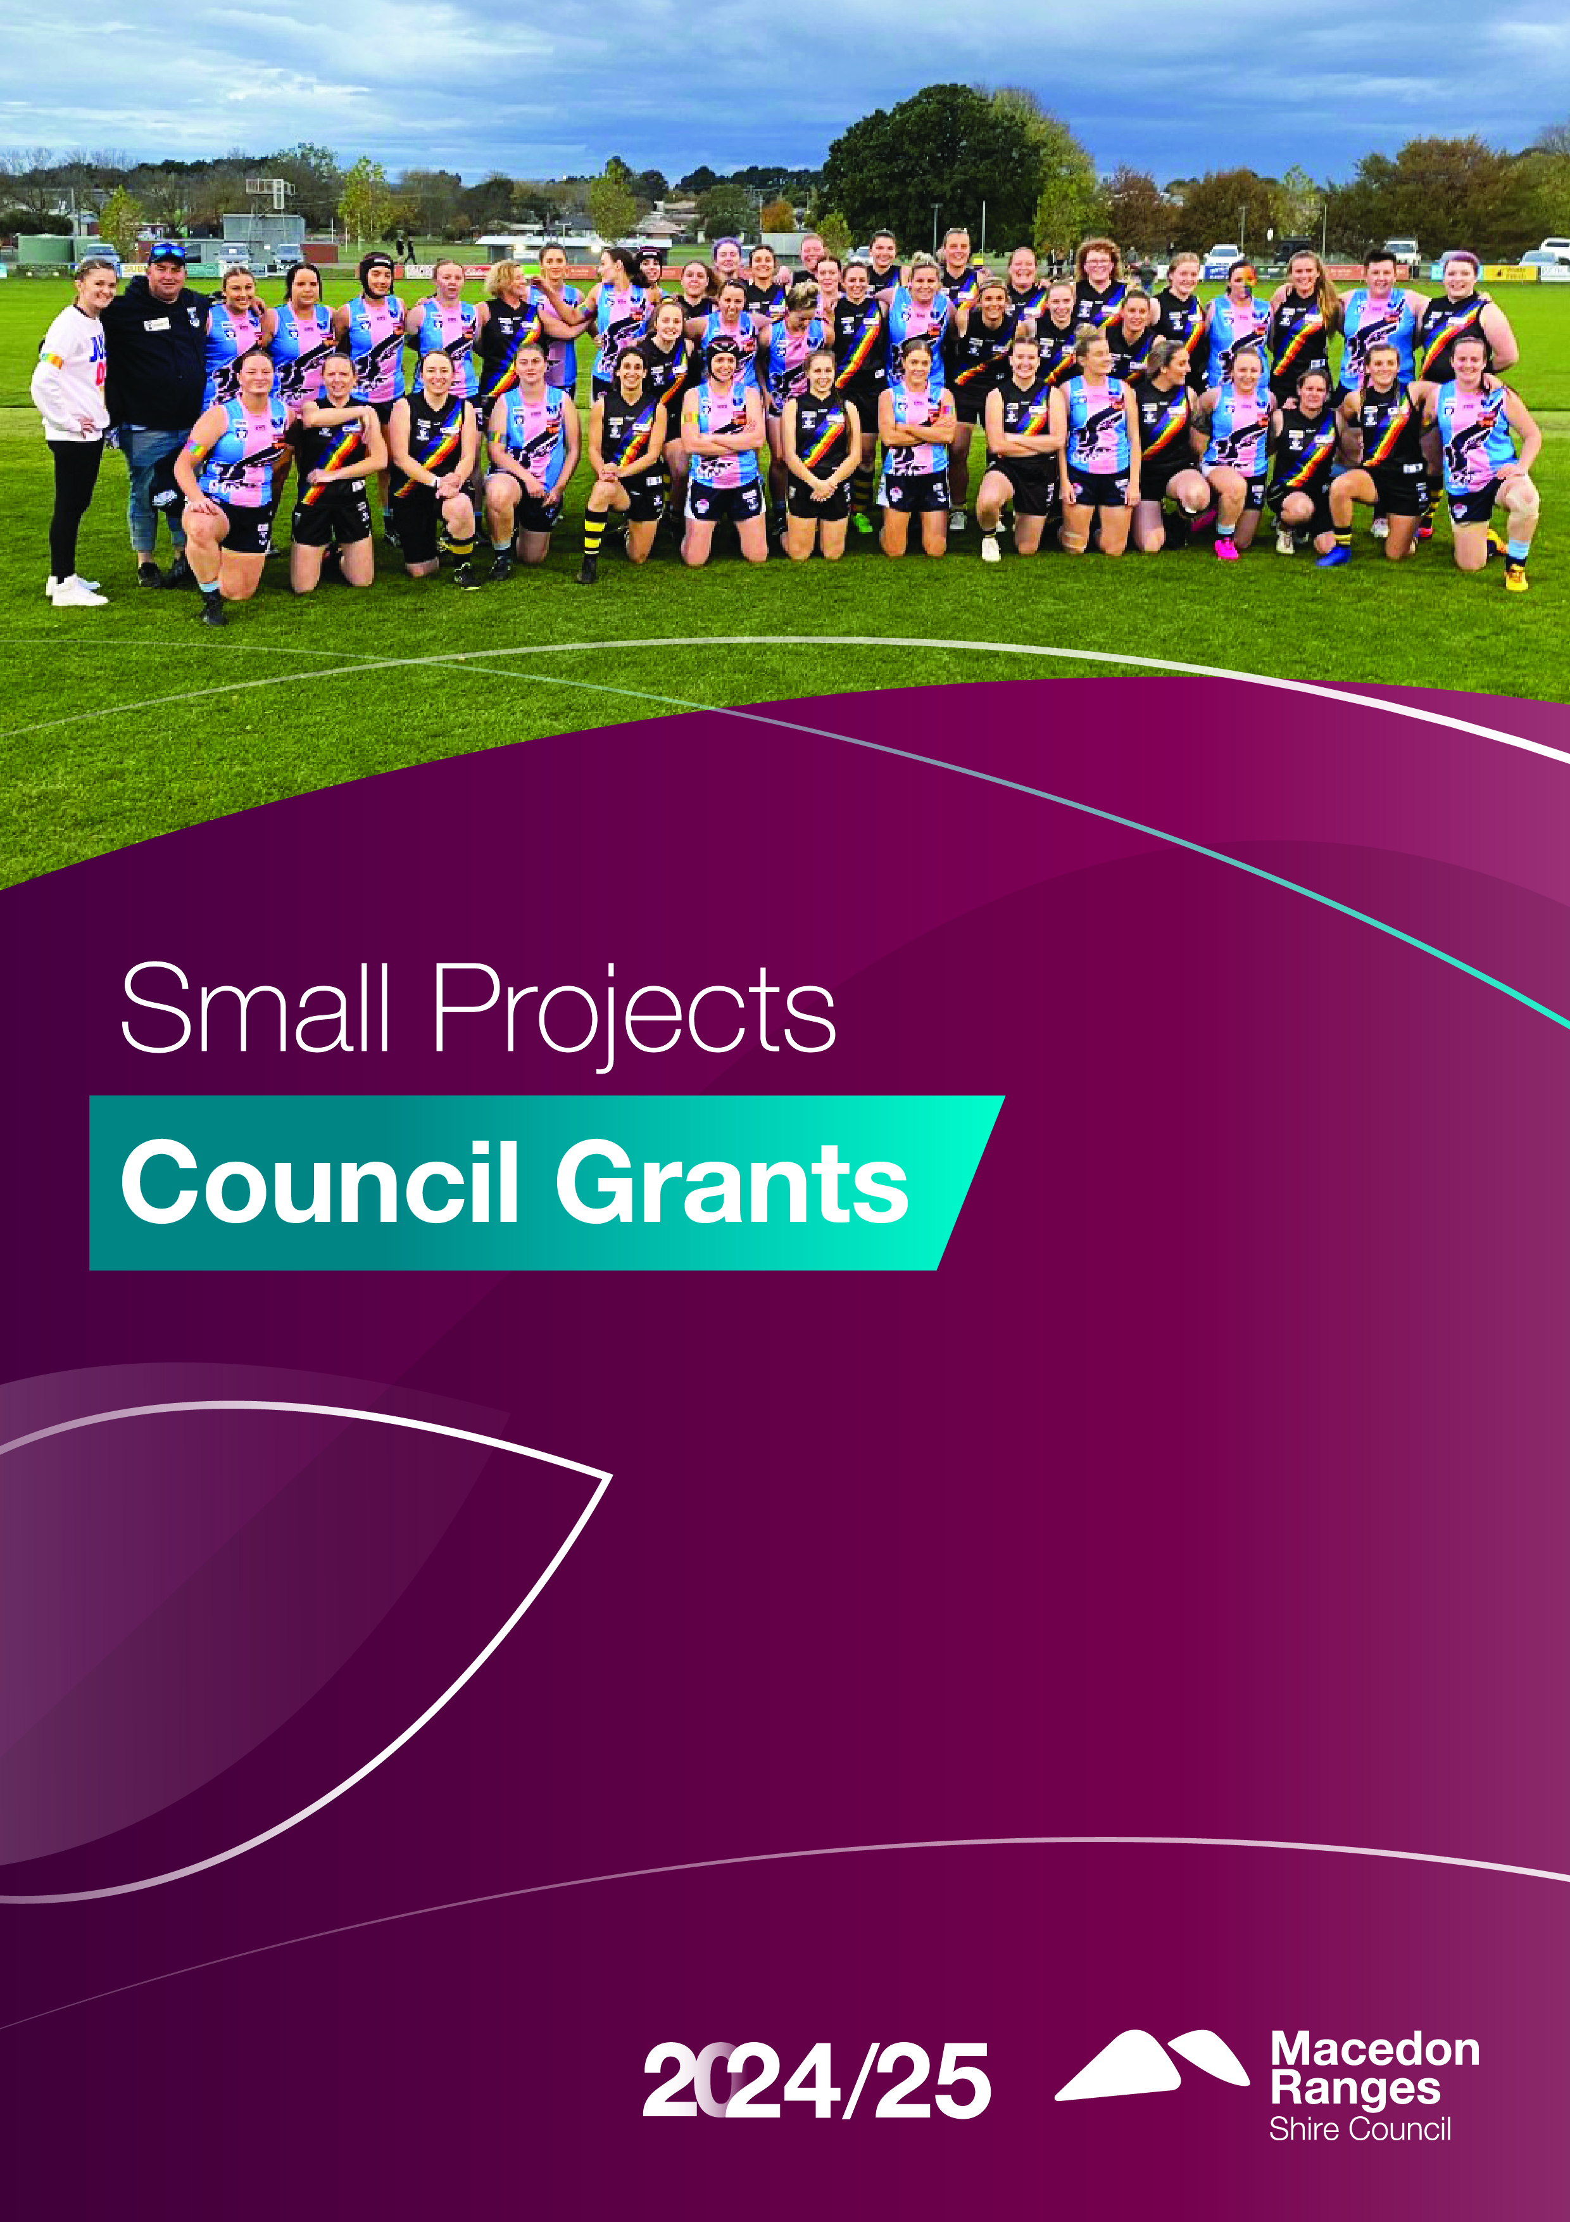

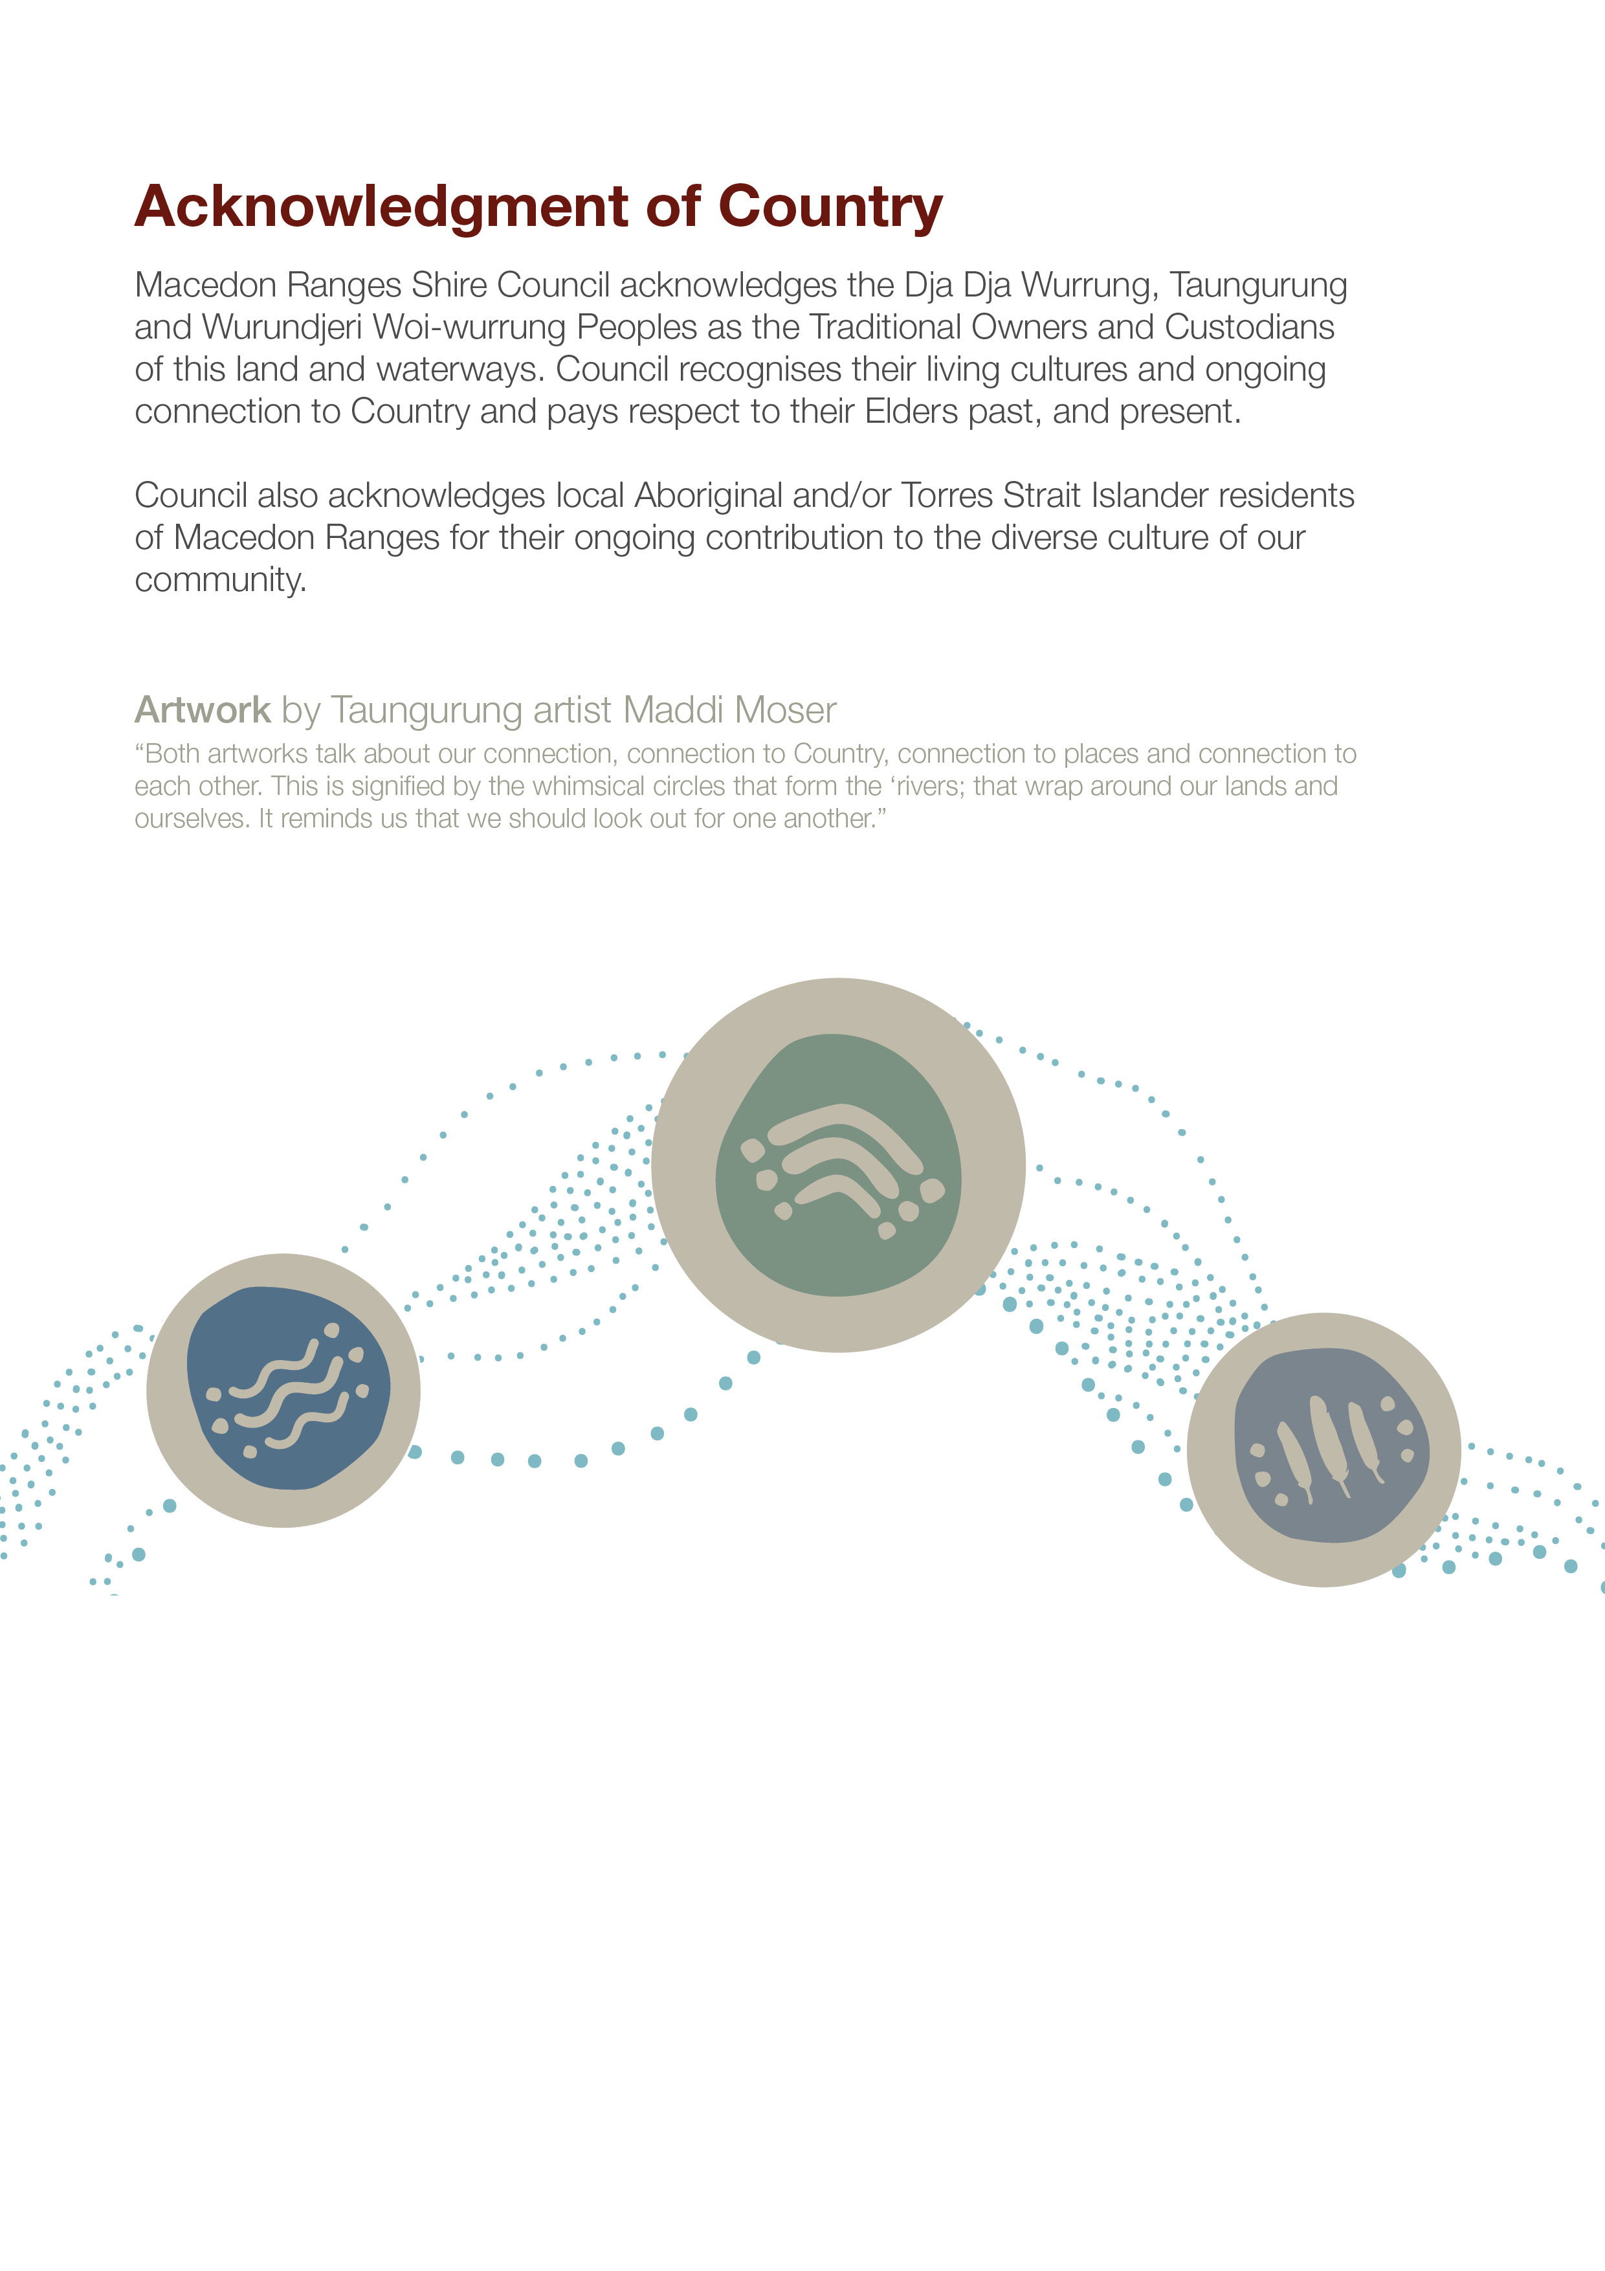
Acknowledgement of Country
Macedon Ranges Shire Council acknowledges the Dja Dja Wurrung, Taungurung and Wurundjeri Woi Wurrung Peoples as the Traditional Owners and Custodians of this land and waterways. Council recognises their living cultures and ongoing connection to Country and pays respect to their Elders past, present and emerging.
Council also acknowledges local Aboriginal and/or Torres Strait Islander residents of Macedon Ranges for their ongoing contribution to the diverse culture of our community.

Contents
Acknowledgement of Country 2
Small Project Grants 4
Opening and closing dates 4
How much is available? 4
Who can apply? 5
Auspicing 5
Eligibility requirements 5
Who will not be funded? 5
Legal requirements 7
Incorporation status 7
Child safe standards 7
Public liability insurance 8
What is the application process? 8
How are applications assessed? 9
Unsuccessful applications 9
What we are looking for in the applications 10
What will strengthen my application? 11
Summary of Council priority areas 11
Budget 13
Conditions 14
Funding agreement 14
Project variation 14
Reporting 14
Incomplete activities/projects and unspent funds 14
Permits, insurance and authorisations 14
Privacy 15

Small Project Grants
Small Project Grants fund public money to not-for-profit community groups and non-government and government schools for programs and initiatives that benefit residents of the Macedon Ranges and help achieve Council Plan goals.
The aim of the Small Project Grants program is to support initiatives which:
- support local needs
- are unlikely to be funded by other Council funding programs
- align with the Council plan priorities of:
- Connecting Communities
- Healthy Environment, Healthy People.

Opening and closing dates
Applications can be submitted online at any time, except during the caretaker period during a Council election year. Please note, once the programs annual budget (listed below) has been exhausted, no further applications will be accepted until the new financial year.
Please also note that from the point at which you submit your application, the assessment/approval process (including endorsement at a Scheduled Council Meeting) may take up to a maximum of eight weeks. Please refer to Council's website for submission dates for each Council meeting.

How much is available?
The Small Project Grants budget for 2024/25 is $30,000.
The program provides grants of up to $3,000 per project to eligible groups for community programs and initiatives.

Who can apply?
Incorporated, community-based not-for-profit groups operating or being established in the Macedon Ranges can submit one application per year.
Incorporated organisations who act as an auspice for another community group for the purpose of this grant may also submit one application for their own organisation per year, in addition to their auspice arrangements.
We welcome applications from all not-for-profit community groups and encourage LGBTQIA+, First Nations and groups who have not applied for funding previously to apply.

Auspicing
If you are unincorporated you will need to find an incorporated organisation willing to act as an auspice for the purpose of this grant. Please refer to Section 6 - Legal Requirements.

Eligibility requirements
Applicants are advised to read the guidelines thoroughly before submitting their application.
Public schools/churches are eligible if they can show a demonstrated need and broad community benefit and participation beyond the school community or congregation respectively. Projects that are entirely school or congregation focussed will not be funded.

Who will not be funded?
The following are ineligible to apply to the Small Project Grant program:
- Individuals
- Political organisations
- For profit/commercial organisations (including private schools)
- Government agencies/organisations
- Groups/auspices that are in debt to Council
- Groups/auspices that have not completed the reporting requirements of previous Council grants.
What will not be funded?
Projects or activities which:
- have already commenced, are recurrent or have been completed
- are commercial, religious, political, discriminatory, sexist, racist or disrespectful
- are considered fundraising/asking for donations
- intend to raise funds beyond what is needed to deliver the project and aim to boost general operating profits
- are the funding responsibility of state or federal government
- promote or involve gambling-related activities
- receive sponsorships from gaming venues, online betting companies or other gambling providers
- do not support responsible drinking
- involve capital and/or infrastructure works
- are defined as facility maintenance on community and Council-owned buildings
- fund capital expenditure (the purchase of land, buildings, vehicles)
- award monetary prizes
- are recreational excursions (camps, holidays, tours)
- duplicate services already operating or planned for in a targeted community
- have been previously funded by Council
- are not well supported by evidence of need and where alternative solutions have not been adequately considered
- do not have broad support amongst the community
- do not have appropriate heritage sign-off, including Aboriginal cultural management (where required)
Core business/operational costs such as:
- salaries for ongoing positions
- rent, insurance, utility costs, debts
- conducting an annual general meeting.

Legal requirements

Incorporation status
Applicants must be registered as an incorporated body or arrange for a legally constituted not-for-profit organisation to manage (auspice) the funds.
Council does not auspice applicants.
For more information on auspice arrangements visit the Not-for-profit Law Information Hub.

Child safe standards
Macedon Ranges Shire Council is committed to a zero tolerance approach to child abuse, through actively promoting child safety and ensuring compliance with the Victorian Child Safe Standards. Victorian organisations that provide services to children are required, under the Child Safety and Wellbeing Act 2005, to ensure that they implement compulsory child safe standards to protect children from harm.
As a Child Safe organisation, Council requires that all grant applicants demonstrate their compliance with the Victorian Child Safe Standards and read/understand Council's Child Safety and Wellbeing Policy and Code of Conduct, available from Council's website. Within the application form, applicants will be required to identify whether their project involves direct or incidental contact with children and young people, and complete either a Child Safe Statement of Commitment or submit their Child Safe Policy and a Child Safe Direct Contact Checklist.
Please note: If your organisation is auspiced for the purpose of this grant, the auspice organisation will also need to meet the Child Safe Standards.
More details on the Child Safe Standards can be found on the Commission for Children and Young People website.

Public liability insurance
Public liability insurance covers incidents that occur during an activity being conducted by a group. All groups must be covered by public liability insurance and be able to provide a valid certificate of currency.
It is the responsibility of the applicant or recipient to arrange appropriate insurance.
Groups without public liability insurance will need an auspice with public liability insurance or can contact Local Community Insurance which offers an affordable public liability scheme for not-for-profit community groups.

What is the application process?
The application process involves a panel assessment with recommendations sent to a Scheduled Council Meeting for endorsement. Depending on when an application is received during Council’s reporting cycle, the entire process may take up to a maximum of eight weeks.
All applicants receive an email of acknowledgement through Council’s online grants management system (SmartyGrants) once their application is submitted.
Chart 1: Application process

How are applications assessed?
Eligible applications are assessed by a panel of staff across the organisation, based on responses provided in the application form. Eligibility does not guarantee funding.
All applications are scored based on the weighted assessment criteria. An application that scores 50 (out of 100) and below will not be recommended for funding and will not be forwarded to Council for consideration. Officers will work with the applicant to explore the possibility of strengthening their application which may result in re-submitting the application.
Funding recommendations are presented to Council for approval.
Council reserves the right to exercise judgement on the appropriateness of funding eligibility criteria in respect to contentious, topical or contemporary issues, or where the project may be perceived to be in conflict with Council objectives, plans, or the wider wellbeing of its residents.
Council decisions are final. Applicants who wish to discuss the outcome of their application are encouraged to contact Council’s Coordinator Community Development.

Unsuccessful applications
The assessment process is rigorous and objective - the scoring matrix available on Council’s website is used to assess applications to a consistent and fair standard.
Your activity/project may not receive funding for a variety of reasons. These are some common reasons for an application not being recommended for funding:
- the project is ineligible (refer to Section 5)
- the application scored 50 or below out of 100 (refer to Section 14).

What we are looking for in the applications
The table below outlines the scoring for each criteria. Referring to this and the details contained in the scoring matrix at the end of these guidelines will help you develop a strong application.

Table 1. Assessment criteria
Weighting | Criteria | What we are looking for
30% | Evidence of need | Statement of need  Letters of support  Unlikely to be funded by other funding programs
20% | Alignment to Council priorities | Demonstrated relationship to Council priorities  Alignment to Council’s wellbeing, environment or reconciliation priorities
30% | Community benefit | Number of people participating in project  Number of people benefiting from project  Impact of the community benefit  Improving gender equity outcomes
20% | Ability to deliver project | Demonstrate sound budget  Demonstrate good project planning  Demonstrate good risk management

What will strengthen my application?
- Applications that address Council’s wellbeing and environmental priorities will score more highly than those that do not. Please refer to page 12 of the Municipal Public Health and Wellbeing Plan 2021-2025 and page 3 of the Environment Strategy. Your application should clearly state how your project or initiative will support/contribute to this priority.
- Applications that consider gender equity and accessibility for diverse community groups and those that advance reconciliation and/or celebrate First Nations Peoples will score more highly than those that do not.

Summary of Council priority areas
Table 2. Council priority areas
Priority area | Council priorities
Environment | - climate emergency  - sustainable transport  - waterway health  - biolinks and habitat links  - waste minimisation  - community engagement and partnerships
Wellbeing | - promoting mental health  - social connection and inclusion  - encouraging gender equity and respectful relationships free from violence  - promoting healthy eating and active living  - preventing harm from tobacco, alcohol and other drugs  - tackling climate change and its impact on health,  - supporting the community to respond to and recover from emergencies  - preventing harm from gambling  - supporting a dementia friendly community  - increasing access to affordable housing
Reconciliation | - initiatives that advance reconciliation and/or celebrate First Nations Peoples will also be highly regarded

Your application will be strengthened and will score higher if you can refer to specific actions from at least one of these strategic documents.
- Council Plan 2021-2031
- Municipal Public Health and Wellbeing Plan 2021-2025
- Environment Strategy
- Disability Action Plan 2021-2025
- Gender Equality Action Plan 2022-2025
- Arts and Culture Strategy 2018-2028
- Macedon Ranges Heritage Strategy 2014-2018
- ELEVATE: Youth Strategy 2018-2028
- CREATE: Municipal Early Years Plan 2021-2025
- PARTICIPATE: Positive Ageing Plan 2020-2025
- Reconciliation Action Plan 2021-2023
- 2019 Healthy Heart of Victoria Active Living Census

Budget
Your budget needs to include all income and expenditure related to the activity/project for which you are requesting funding. See a sample budget below:
Table 3. Income
Grant from Council (this application) | $ 3,000
Cash contribution from group | $ 500
Total income (please calculate) | $ 3,500

Table 4. Expenditure
Venue Hire | $500
Guest speaker | $1,000
Welcome to Country and Smoking Ceremony | $1,000
Marketing and Promotion | $500
Printing | $500
Total expenditure (please calculate) | $ 3,500

For groups who are registered for GST, GST will be added to the amount requested.
Grants to recipients not registered for GST will be made exclusive of GST.
For information about GST and ABNs contact the Australian Taxation Office.

Conditions

Funding agreement
Successful applicants will abide by the terms and conditions of a funding agreement.
Activities/projects must be completed within twelve months of receiving funding.
Funds must be spent on the activity/project as described in the application.

Project variation
Applicants must contact the Grants Team to discuss any changes or delays to their project that may require an extension or variation. They will then be provided access to a variation/extension request form via Smarty Grants. Recipients should not undertake any changes until they have written approval following this request.

Reporting
Successful applicants are required to submit a report (acquittal) on grant monies spent upon completion of their activity/project by the date set out in the funding agreement.
Groups who do not submit an acquittal will not be eligible to apply for further funding from Council until the activity/project has been acquitted.
Groups who have been auspiced for the purpose of this grant will need to ensure the auspice organisation has received and approved all acquittal information.

Incomplete activities/projects and unspent funds
If an activity/project can no longer be completed, please contact Council. Any unspent funds are to be returned to Council.

Permits, insurance and authorisations
The applicant is responsible for any regulatory and statutory requirements associated with the activity/project, such as planning and building permits and public liability insurance.

Privacy
The collection and handling of personal information is in accordance with Council’s Privacy Policy which is displayed on Council’s website and available for inspection at, or collection from, Council’s customer service centres.

An application for donations/fundraising activities is regarded as a request for sponsorship and therefore ineligible for a Small Project Grant.
Please refer to the terms of your maintenance schedule in your lease/licence agreement.

