 **Amazing organics!**

Help the organic waste find its way through the maze. 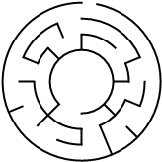

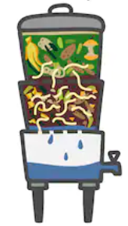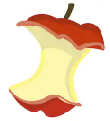

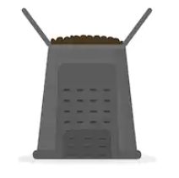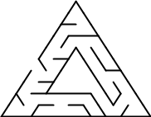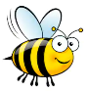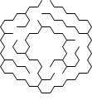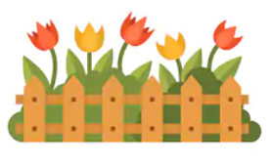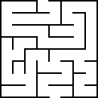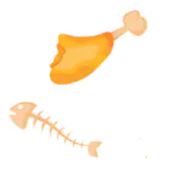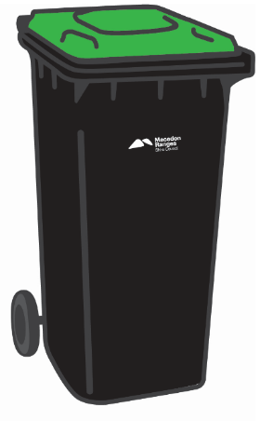

1. Bees love flowers and healthy gardens. Help the bee find the flowers through the honeycomb maze.
2. Leaves make great compost. Put the leaves in the compost bin through the triangle maze.
3. Worms love apples! Put the apple core into the worm farm through the circle maze.
4. FOGO loves seafood, meat, bones and other organic waste that worms don’t like.  
     
   Put the food scraps in the FOGO bin through the square maze.